**AP Review 2016**

**Biochemistry**

**Functional groups**

* 1. **Hydroxyl group** --OH. Called alcohols. OH is polar. (Don’t confuse with the OH- ion).
  2. **Carbonyl group** –C=O. If at end, called aldehyde, otherwise a ketone.
  3. **Carboxyl group** –COOH. Called carboxylic acids or organic acids. Acidic because the H+ tends to dissociate from the O because of the electronegativity of the O’s.
  4. **Amino group** – NH2. Called amines or amino acids if they also have a carboxyl group. Amino groups can pick up H+, acting as bases.
  5. **Sulfhydryl group** – SH. Called thiols.
  6. **Phosphate group** –PO4. Functions in transfer of energy, ex. ATP.

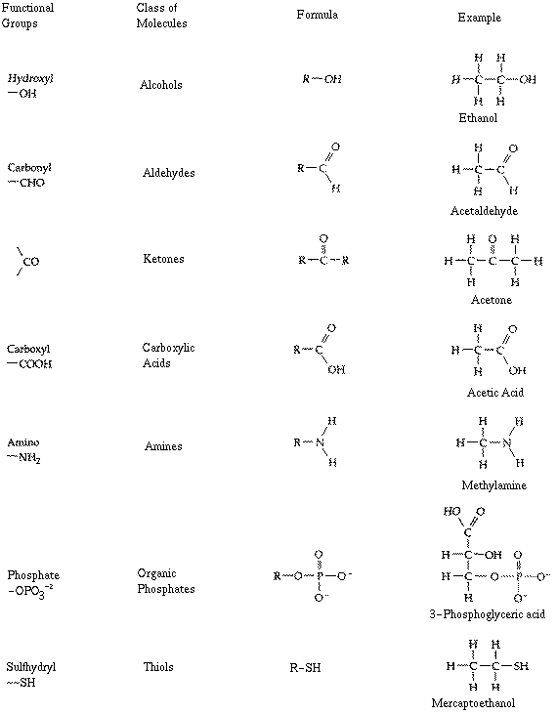

**Hydrolysis** – adding H20 to break apart polymers

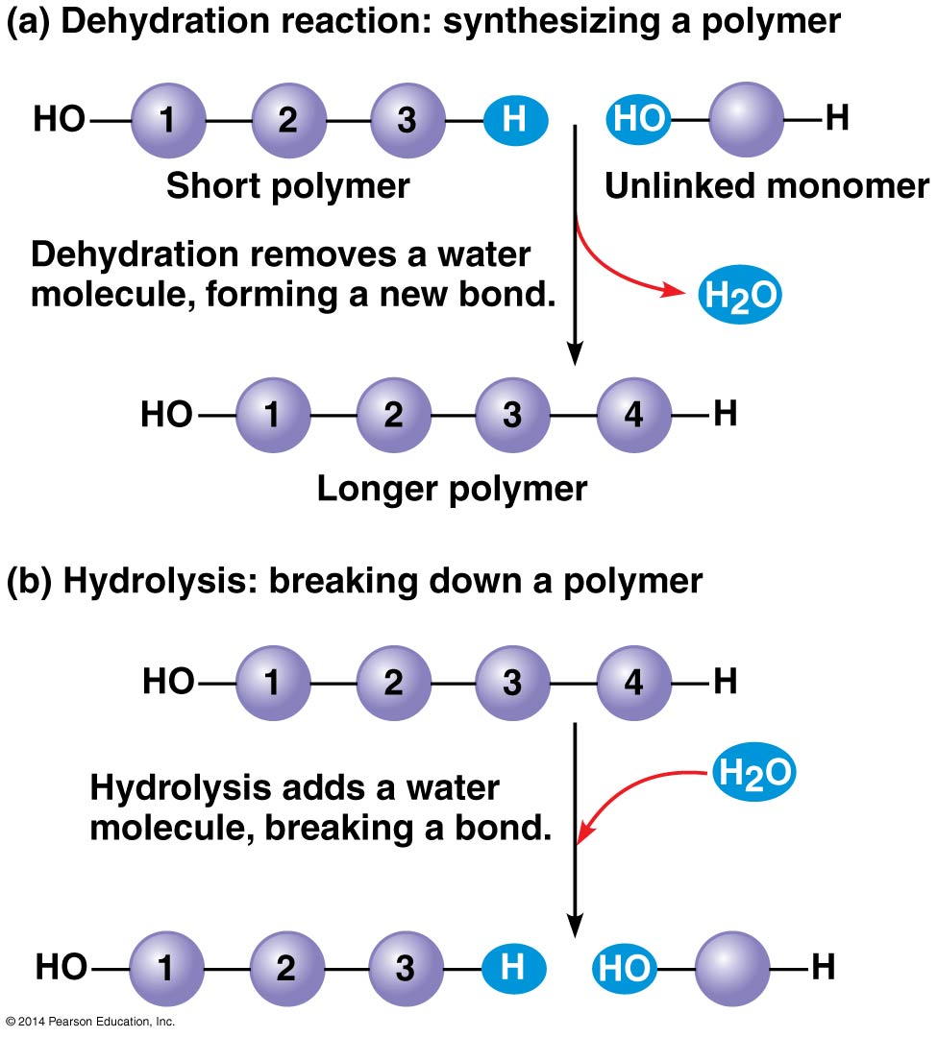

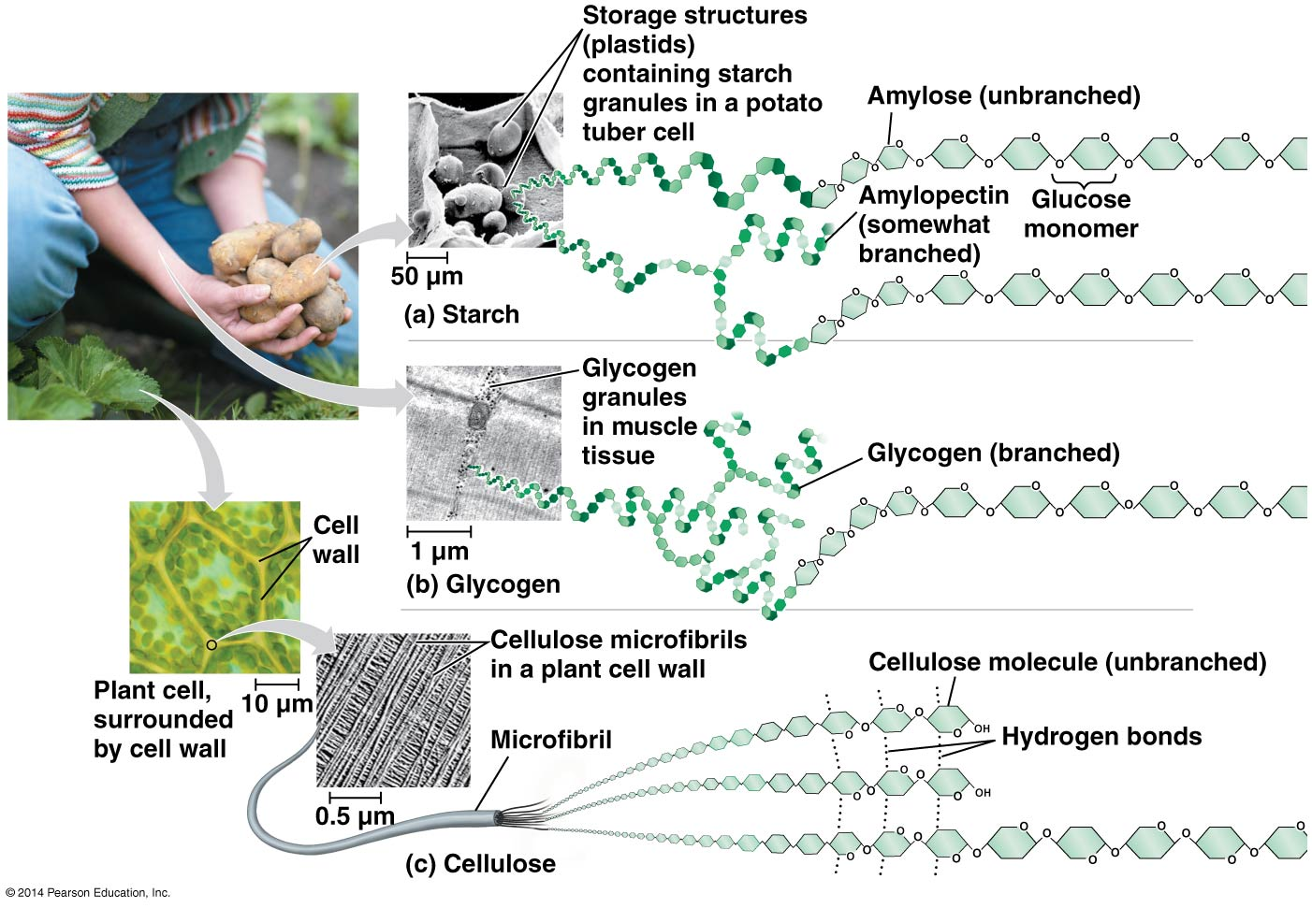

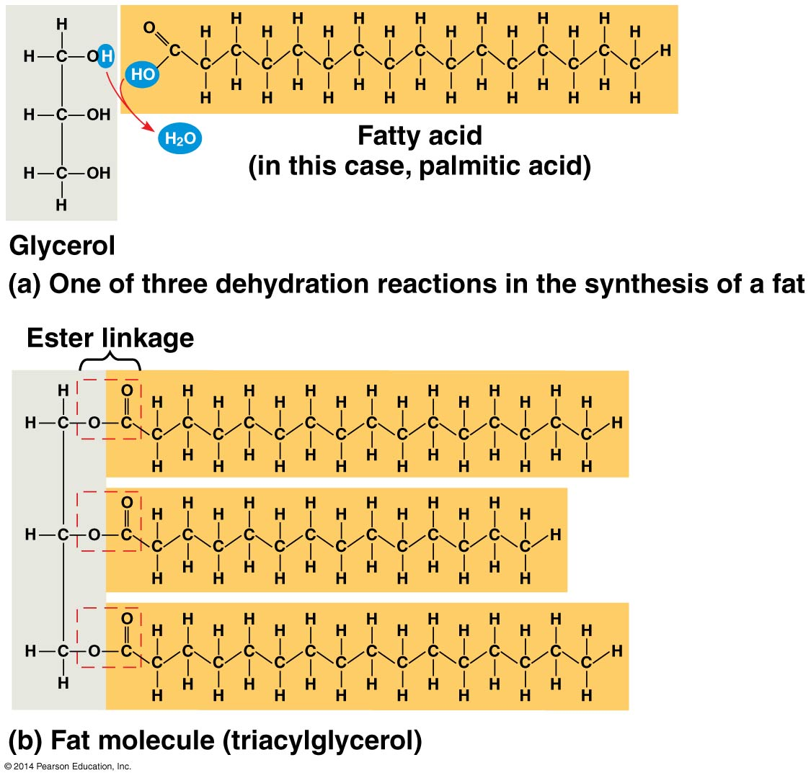

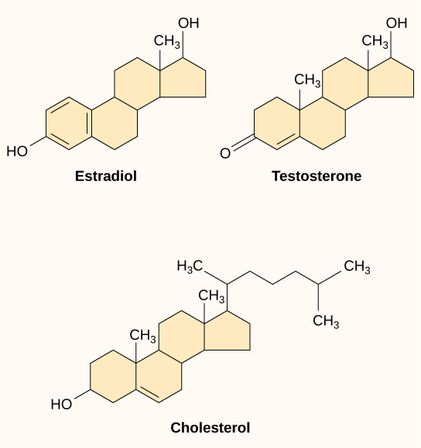

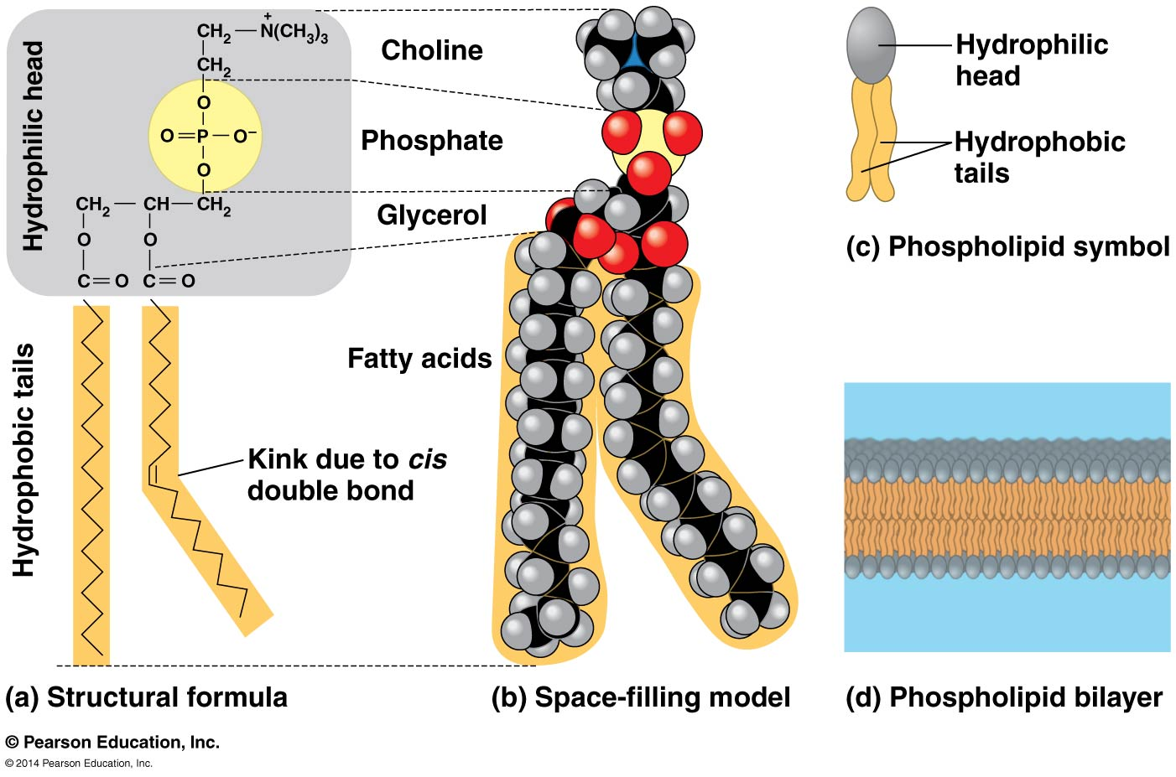

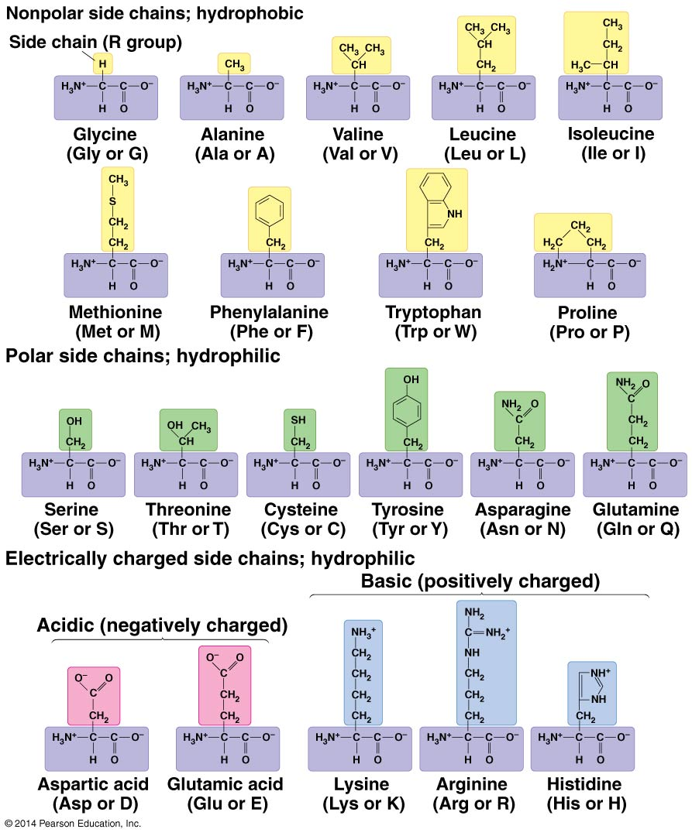

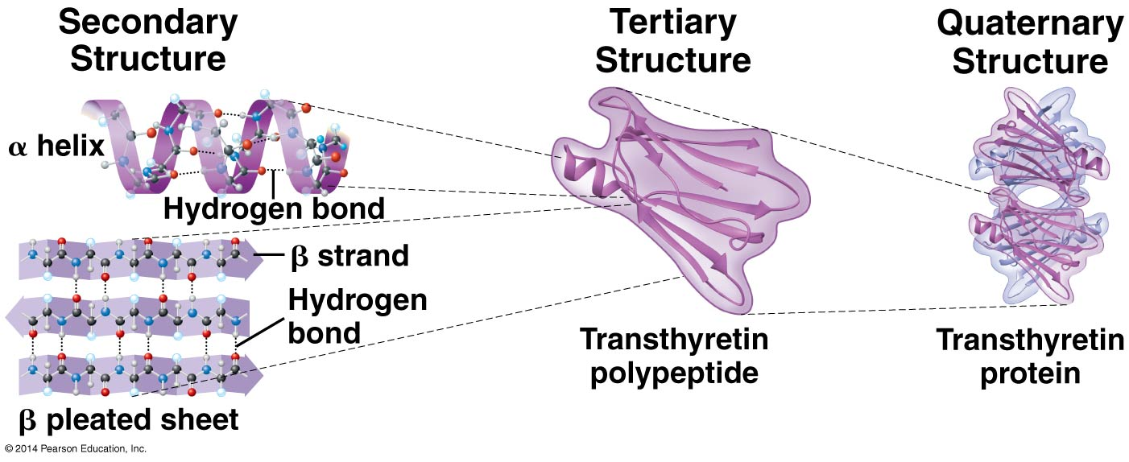

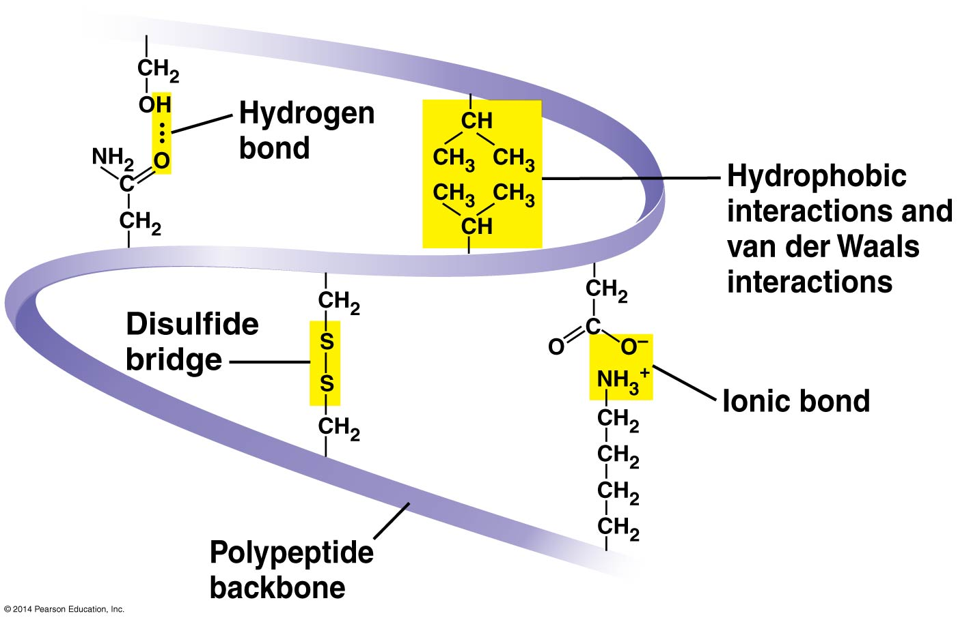

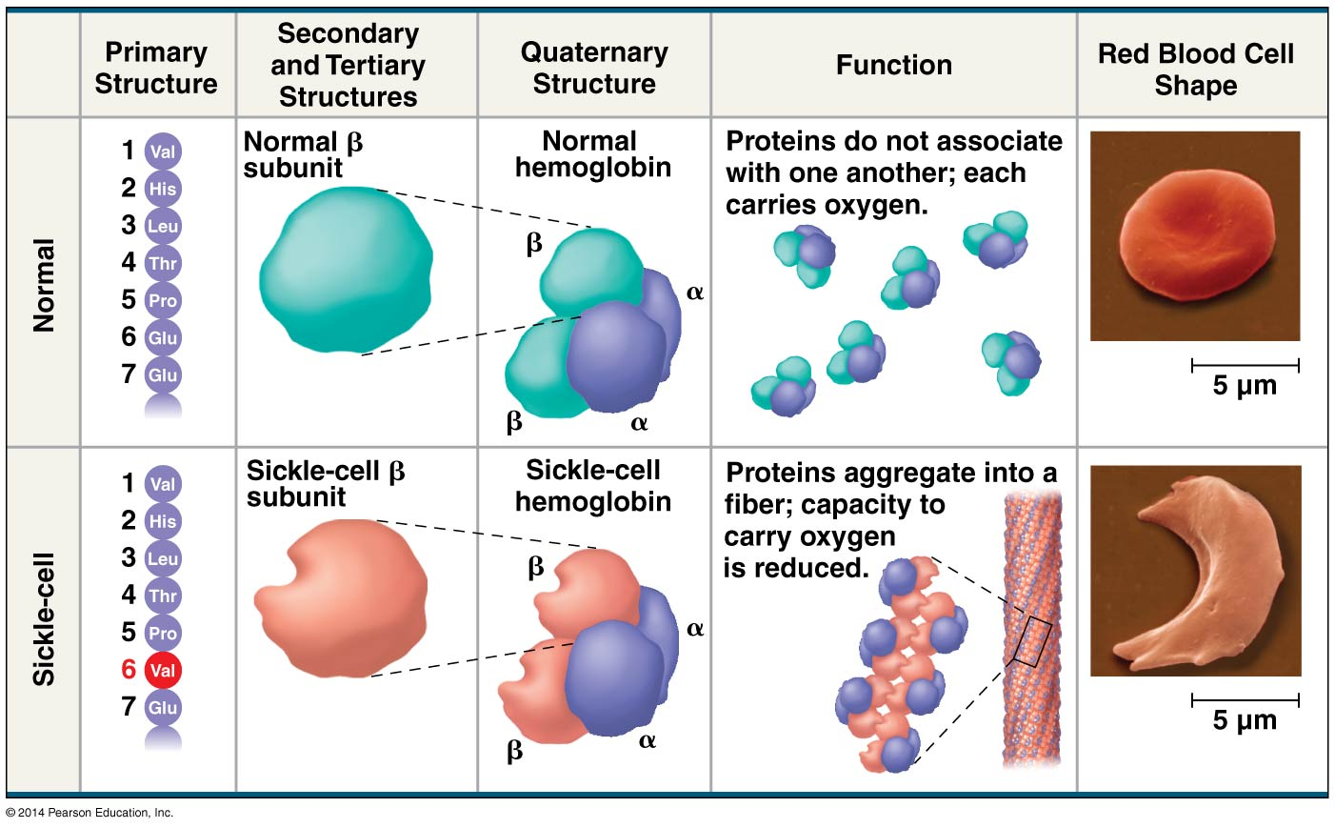

Cells

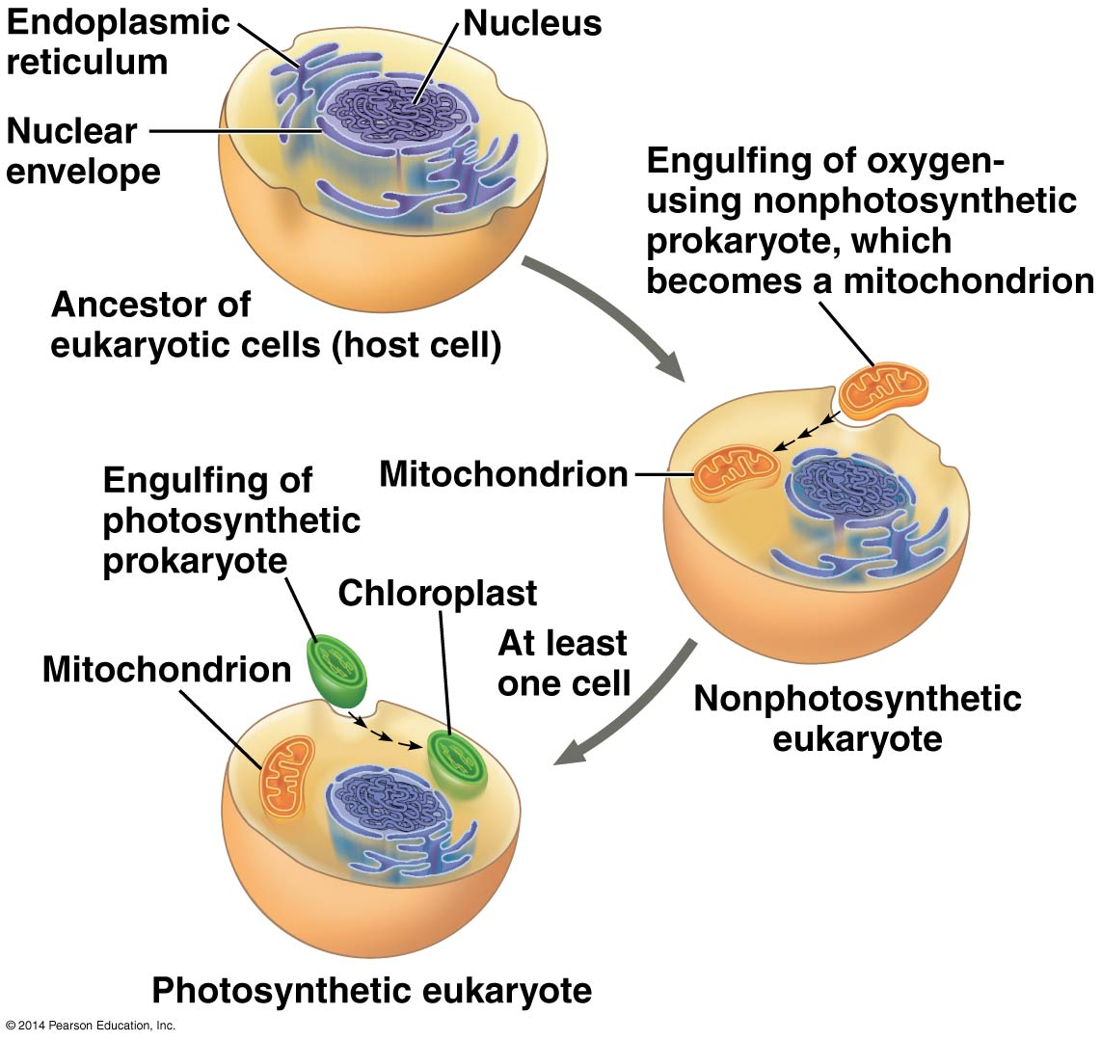

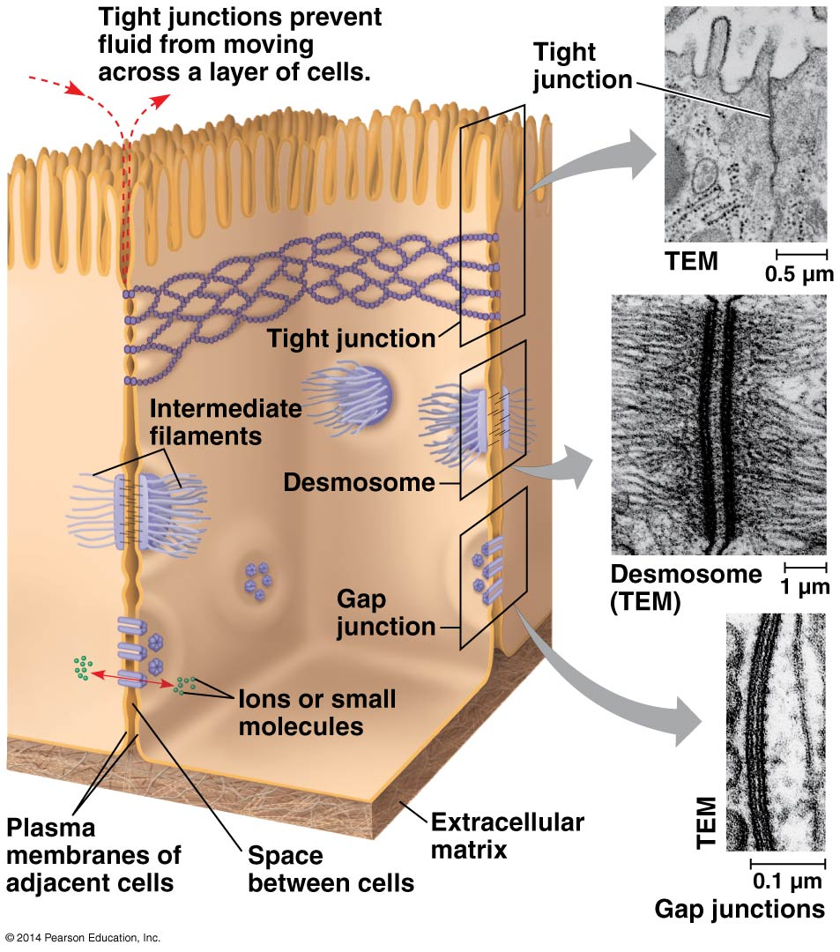

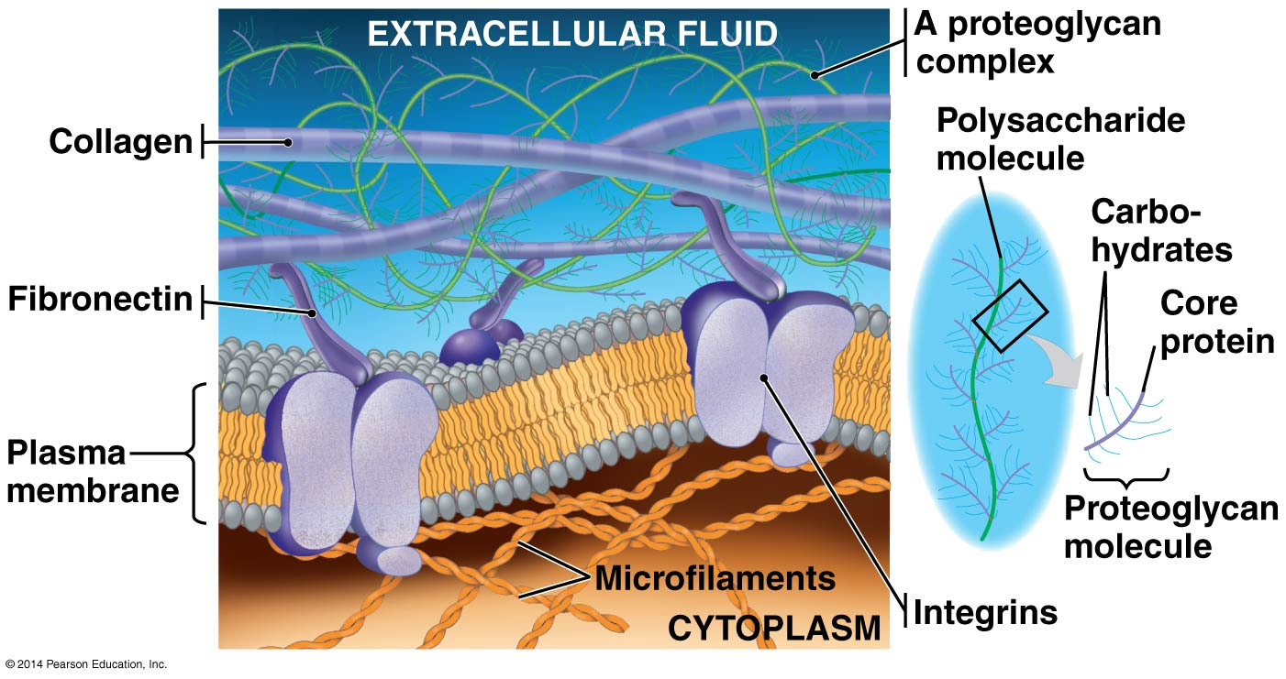

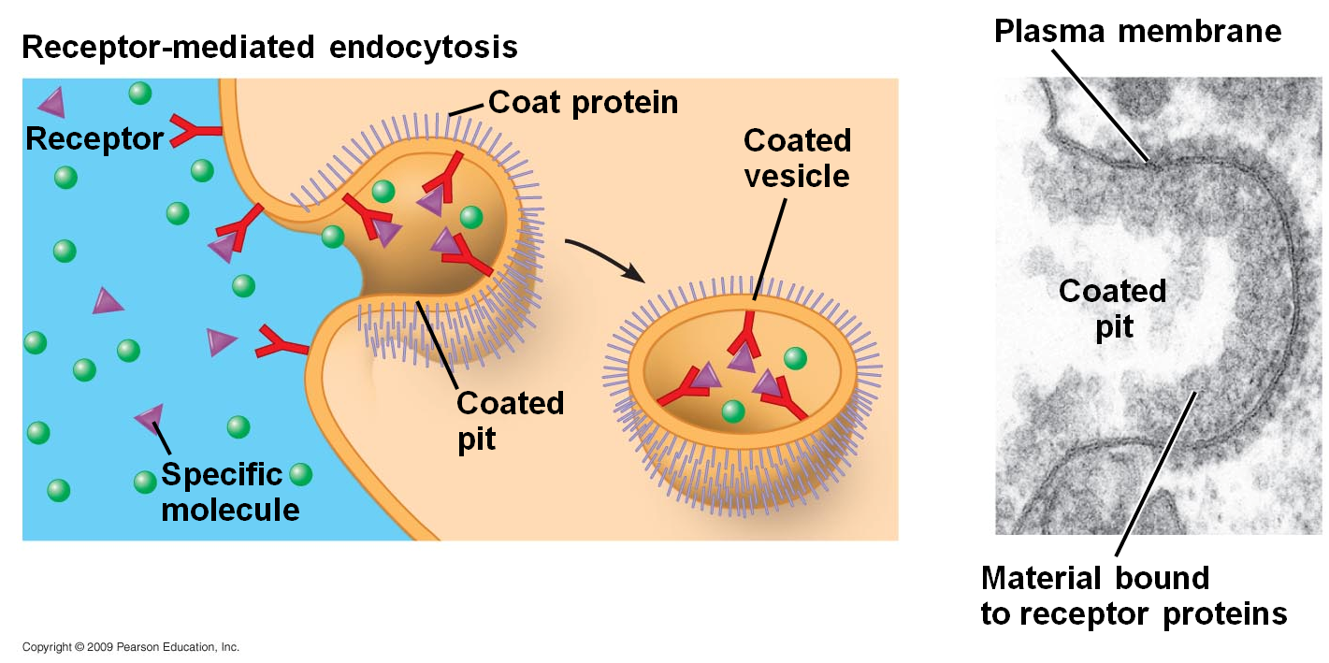

**Exergonic reaction** – occurs spontaneously and releases free energy, ∆G is negative  
  
**Endergonic reaction** – absorbs free energy from its surroundings, ∆G is +

**Work cells do** (powered by ATP)  
1. Mechanical work, ex. beating of cilia, muscle contraction  
2. Transport work, ex. pumping substances across membranes against a concentration gradient  
3. Chemical work, ex. pushing reactions that would not occur spontaneously, such as synthesis of polymers  
  
**Adenosine triphosphate** (ATP) – made of adenine (N base), ribose, and 3 phosphate groups

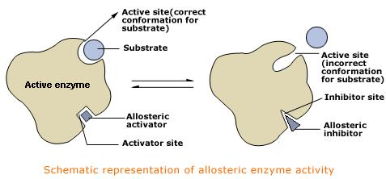

**Control of metabolism:**   
• Pathways controlled by switching on/off genes that encode specific enzymes, or by regulating the activity of enzymes once they’re made.  
• **Allosteric site** – a specific receptor site on some part of the enzyme, but NOT the active site. Some enzymes have >1 active site.  
• **Feedback inhibition** – switching off of a metabolic pathway by its end-product, which acts as an inhibitor of an enzyme within the pathway. Prevents wasting chemical resources.  
• **Cooperativity** – the binding of one substrate molecule causes all the subunits in enzymes with >1 active site to assume active conformation.  
• **Cell organization** aids in keeping order in metabolism, ex. enzymes for cellular respiration stay in the mitochondria.

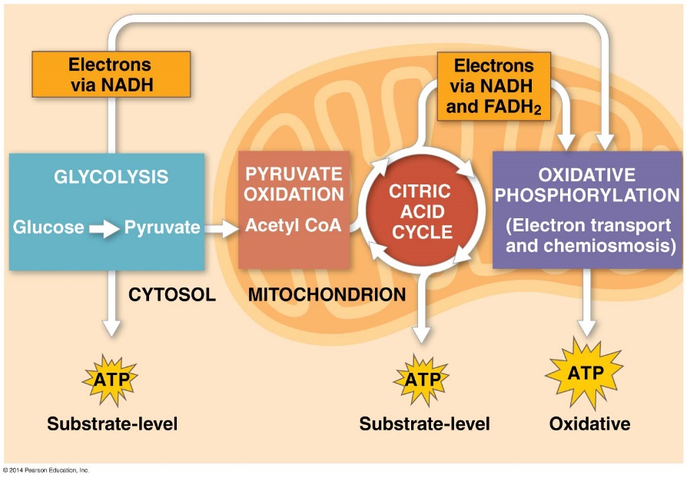

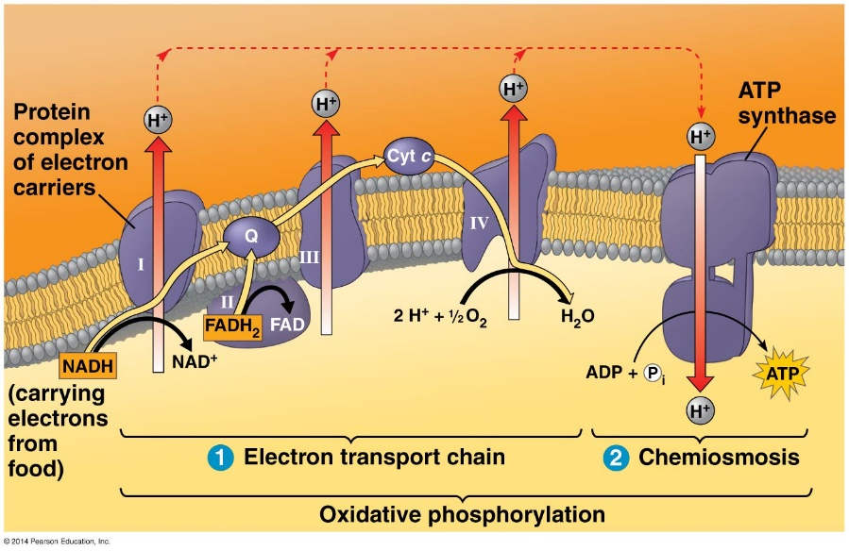

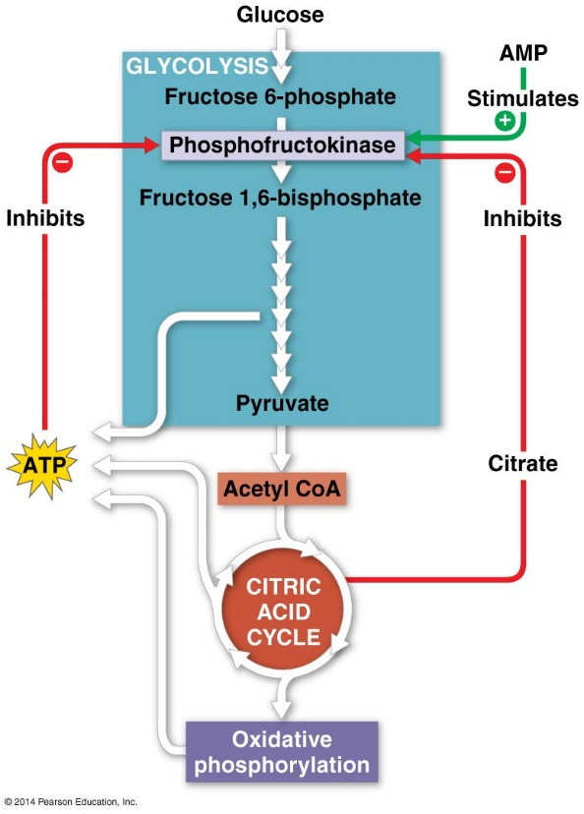

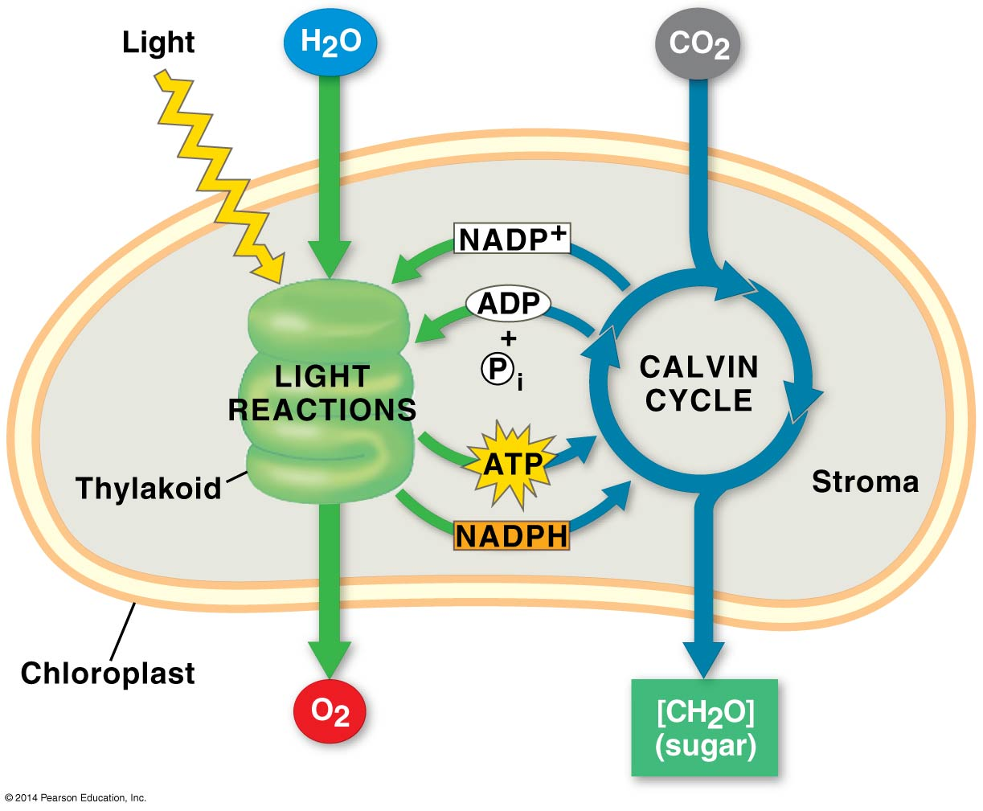

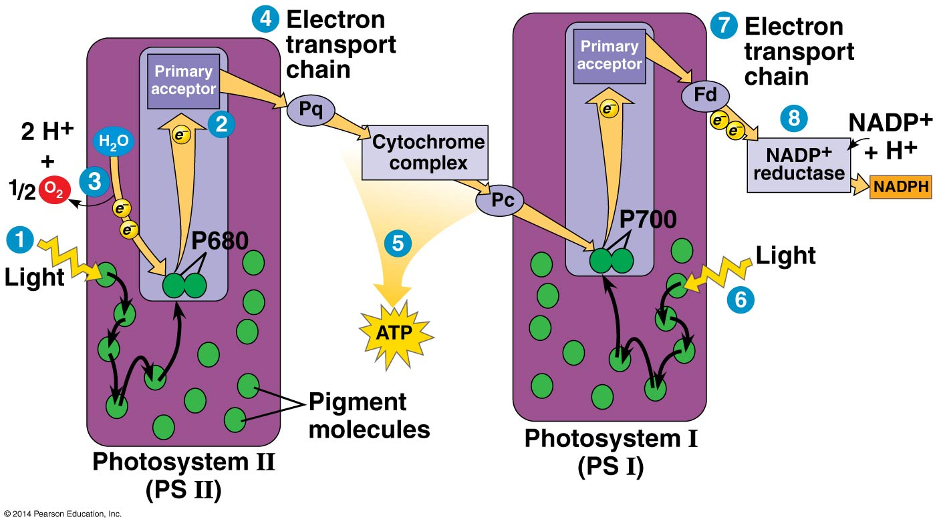

* **Noncyclic photophosphorylation** – ATP made during noncyclic electron flow.
* **Cyclic electron flow** – route of electron flow that involves only photosystem I and produces ATP, but **not** NADPH or O2. Functions to make up the difference, as Calvin cycle consumes more ATP than NADPH.

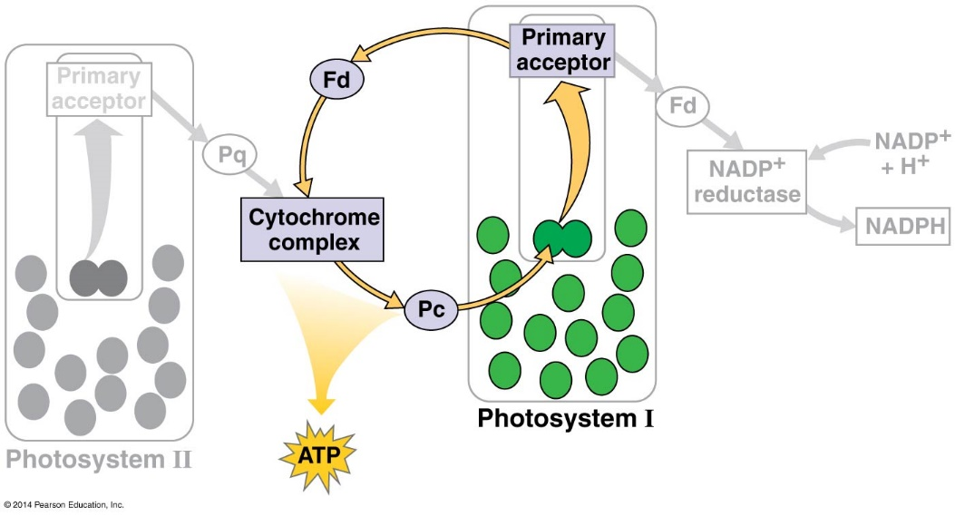

**Chemiosmosis** (making ATP using H+ gradients across membranes)

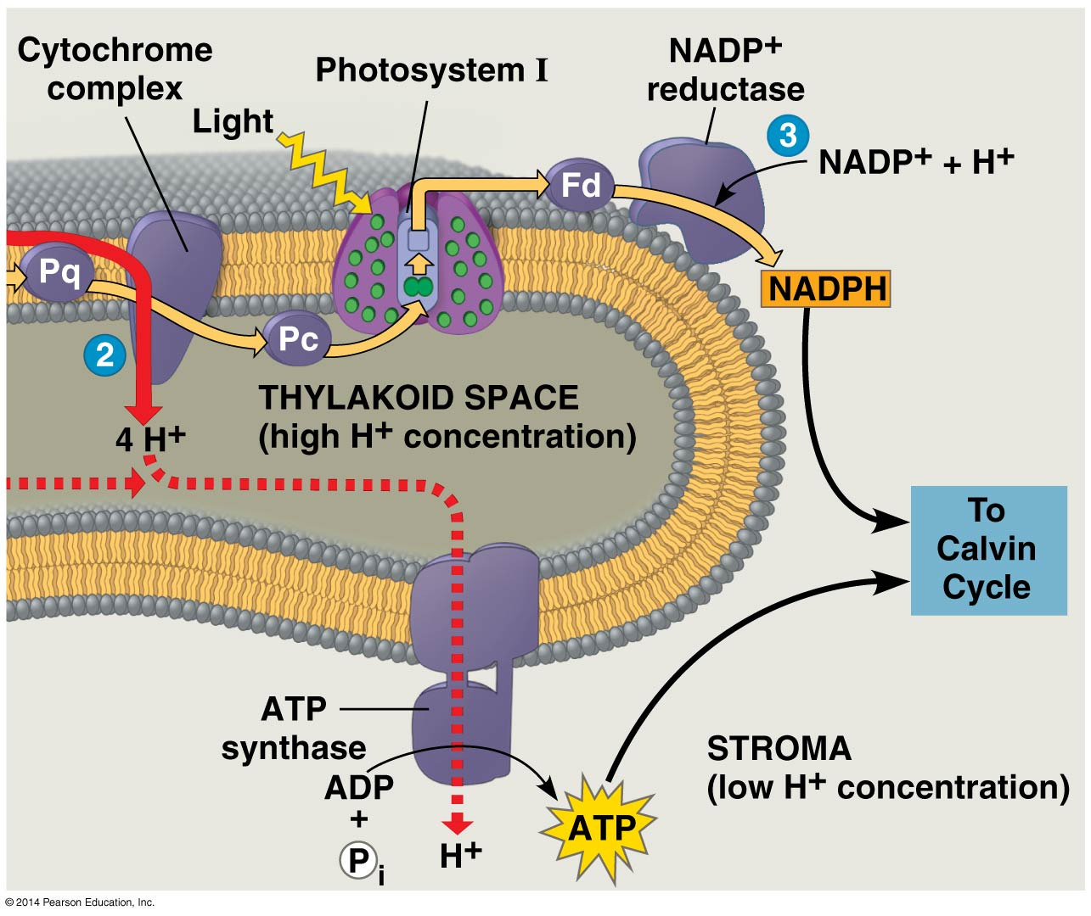

Alternative mechanisms:

* **Photorespiration** – metabolic pathway that consumes O2, releases CO2, makes **no** ATP, and decreases photosynthetic output. NOT KNOWN if it’s beneficial to plants in any way. Thought to be relic of times when O2 concentration low and CO2 high. Occurs on hot, dry, bright days when stomata close and O2 concentration in leaf exceeds that of CO2.
* **C3 plants** – first organic product of C fixation is 3-C compound, **most plants** like rice, wheat, soybeans. Rubisco is the primary enzyme
* **C4 plants** – first organic product of C fixation is 4-C compound, found in several thousand species including sugarcane and corn. Uses unique leaf anatomy and PEP carboxylase instead of rubisco as primary enzyme. Because PEP carboxylase has higher affinity for CO2, it is more efficient when CO2 low. Mesophyll cells pump CO2 into the bundle sheath. Thought to have evolved in hot, intense sunlight regions and thrive there today.
* **CAM plants** – crassulacean acid metabolism. Evolved in water-storing plants, including cacti and pineapples. Open stomata during night and close them during day, opposite of other plants. Incorporate CO2 into a variety of organic acids (also 4C) synthesized into sugar during daylight.

