C10 Photosynthesis (video)

Autotrophs – producers, make organic molecules from inorganic
- Photoautotrophs – use light as energy source to make carbohydrates, lipids, proteins, and other organic substances
- Chemoautotrophs – produce organic compounds by oxidizing inorganic substances, such as S or NH₃.

Green parts of plants contain chloroplasts. Leaves are major sites of photosynthesis. ~500,000 chloroplasts/mm² leaf surface. Most chloroplasts found in mesophyll. CO₂ enters leaf through stomata-mouth-like openings.

Chlorophyll – green pigment in chloroplasts that absorbs light energy

Equation:
6 CO₂ + 6 H₂O + light energy → C₆H₁₂O₆ + 6 O₂

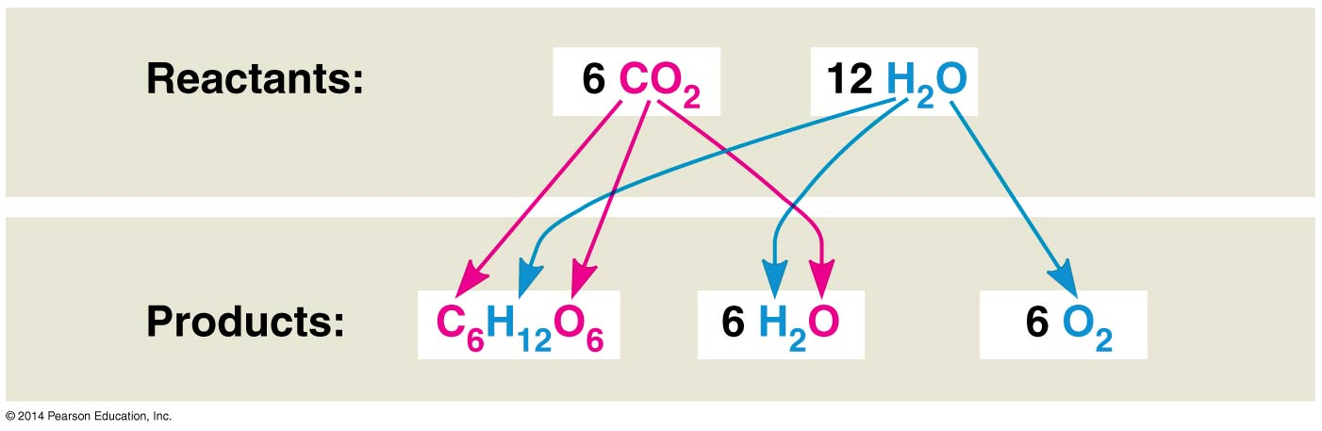

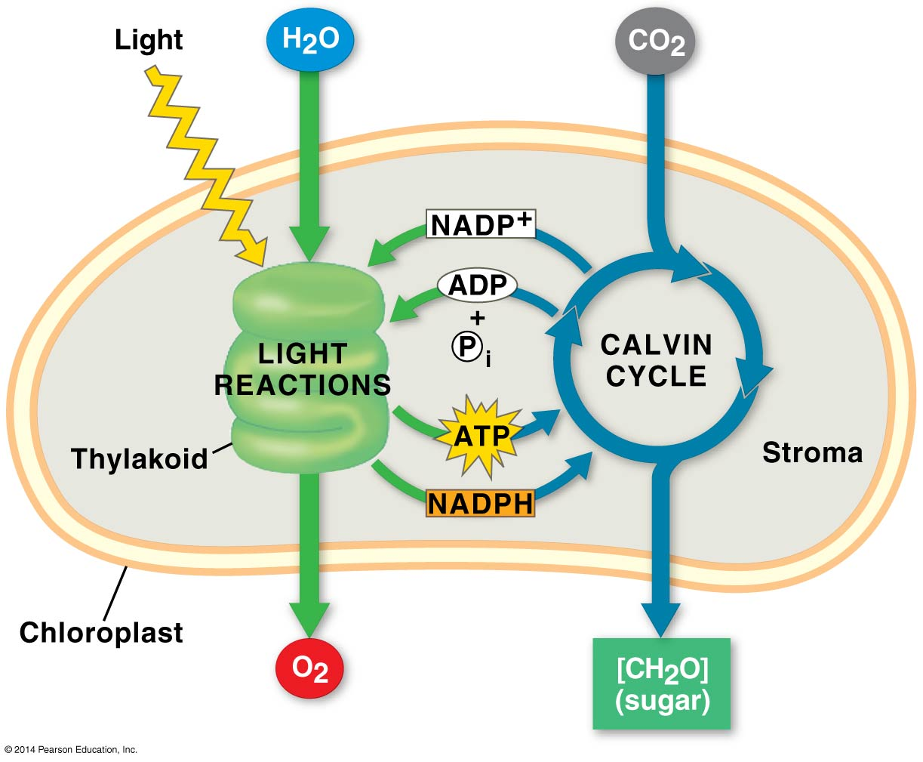
Light dependent reaction:
- Occurs in thylakoid discs
- Water is split producing the O₂ we breathe and H⁺
- Electrons and H⁺ are accepted by NADP⁺ (nicotinamide adenine dinucleotide phosphate)
- Photophosphorylation – generating ATP from ADP + P with light energy
- Photons – “particles” of light whose energy is inversely related to wavelength (λ) of light; shorter λ has greater energy; violet has ~2X more energy than red
- Blue and red light are most useful in photosynthesis because chlorophyll absorbs these, while reflecting green
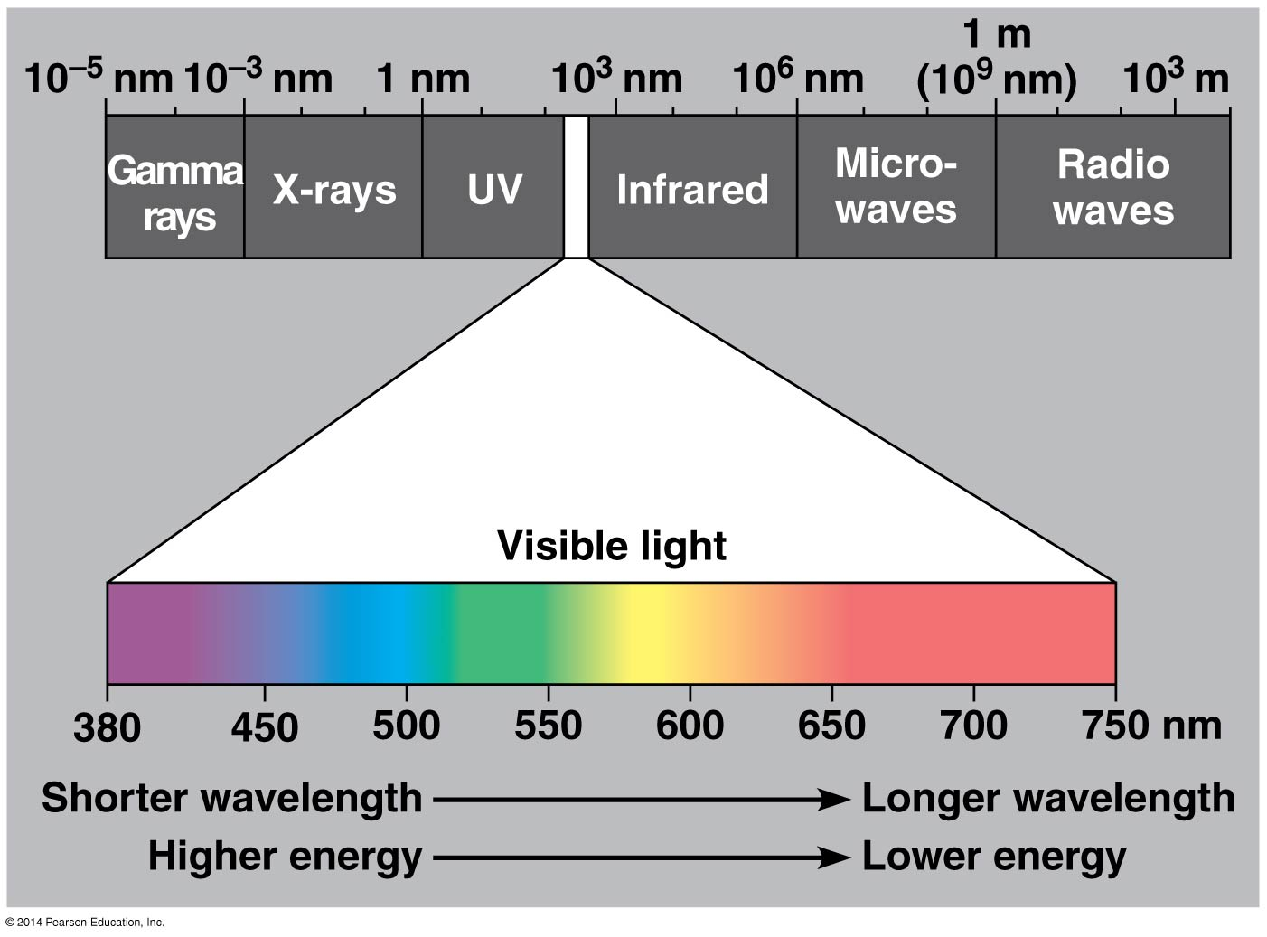

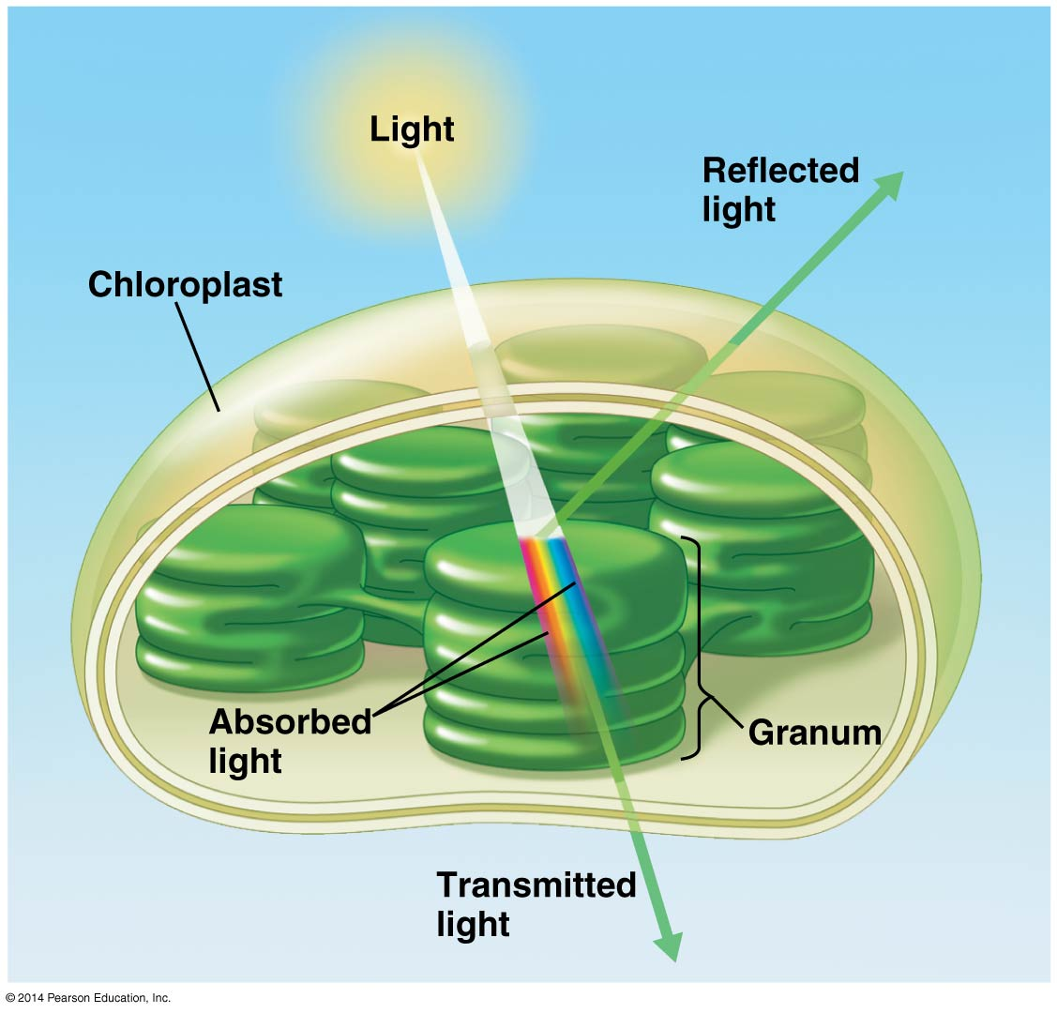

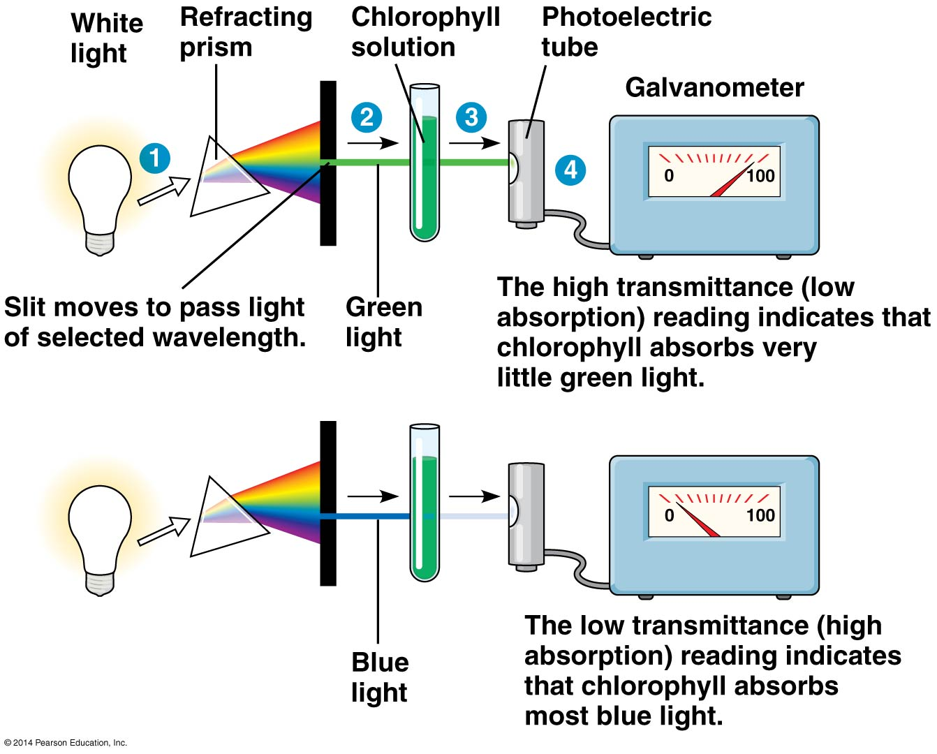
- Chlorophyll a – blue-green, primary pigment in photosynthesis
- Chlorophyll b – yellow-green, accessory pigment, transfers absorbed energy to chlorophyll a
- Carotenoids – yellow and orange pigments, some help drive photosynthesis; others function in photoprotection (absorb and dissipate excessive light energy that would damage chlorophyll)
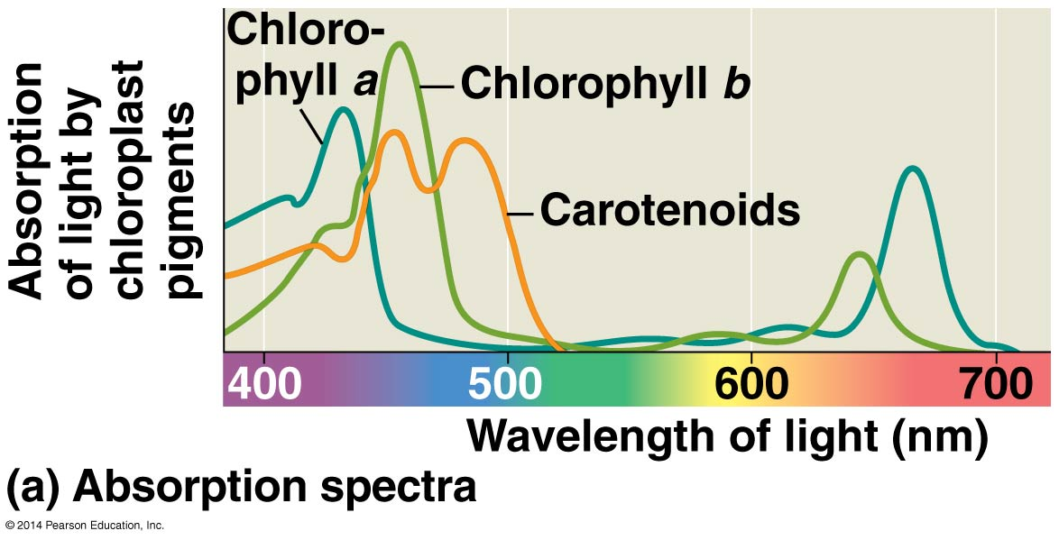
- Reaction center – region of photosystem where the first light driven chemical reaction of photosynthesis occurs.
- Photosystem I –P700 absorbs light best at 700 nm
- Photosystem II – P680 absorbs light best at 680 nm
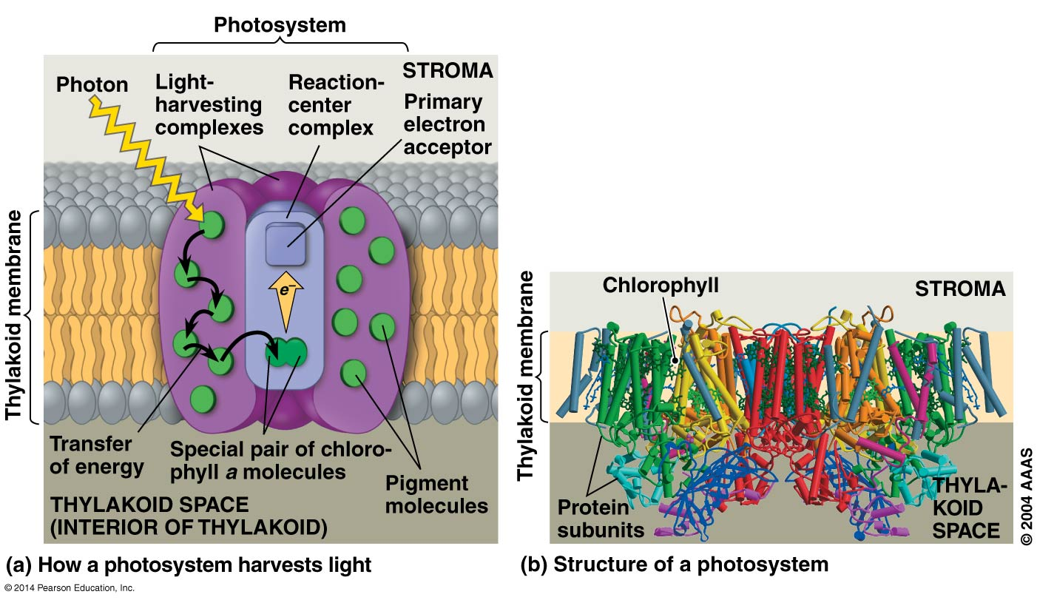
- Noncyclic electron flow (Linear) – route of electron flow that involves both photosystems and produces ATP, NADPH, and O₂; net electron flow is from water to NADP⁺. Photoexcited electrons pass from the primary electron acceptor of photosystem II to photosystem I via an ETC. NADPH and ATP are produced in ~equal quantities here.
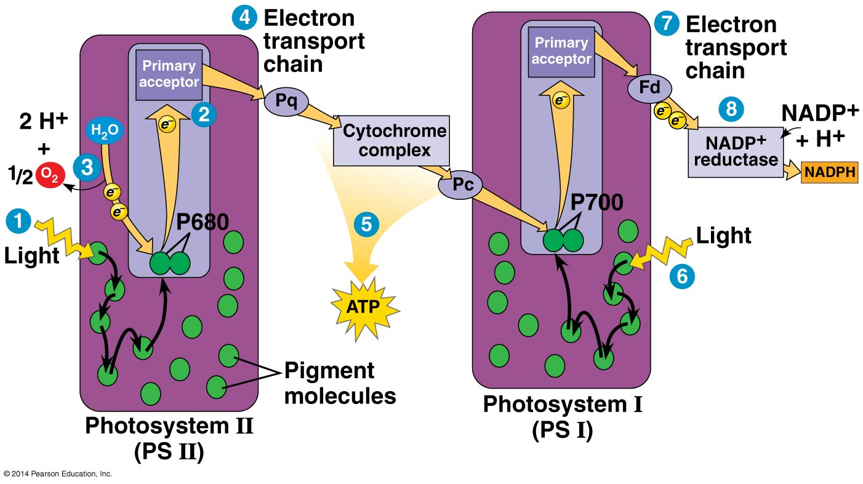
- Noncyclic photophosphorylation – ATP made during noncyclic electron flow.
- Cyclic electron flow – route of electron flow that involves only photosystem I and produces ATP, but not NADPH or O₂. Functions to make up the difference, as Calvin cycle consumes more ATP than NADPH.
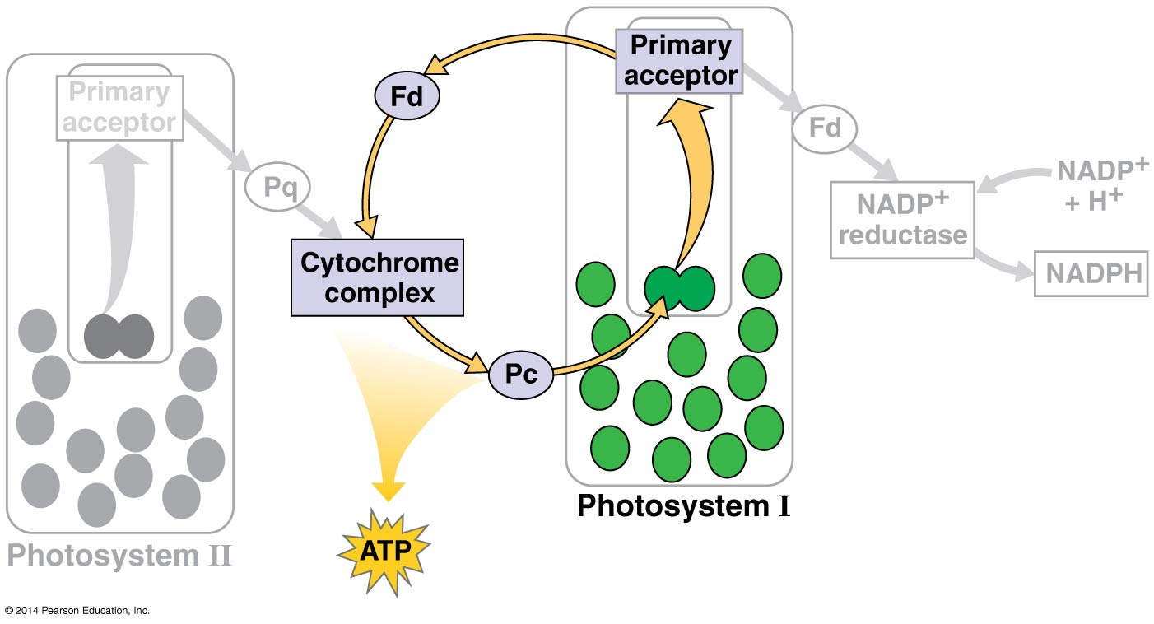
- Cyclic photophosphorylation – ATP made during cyclic electron flow.
- Concentration of NADPH in chloroplast thought to help regulate which pathway, cyclic or noncyclic, electrons take through light reactions.
- Chemiosmosis (making ATP using H⁺ gradients across membranes) is very similar in chloroplasts and mitochondria. Biggest difference is source of energy. Light energy powers photophosphorylation. Oxidation of food molecules powers oxidative phosphorylation. Chloroplast uses thylakoid space as H⁺ reservoir and mitochondria uses intermembrane space.
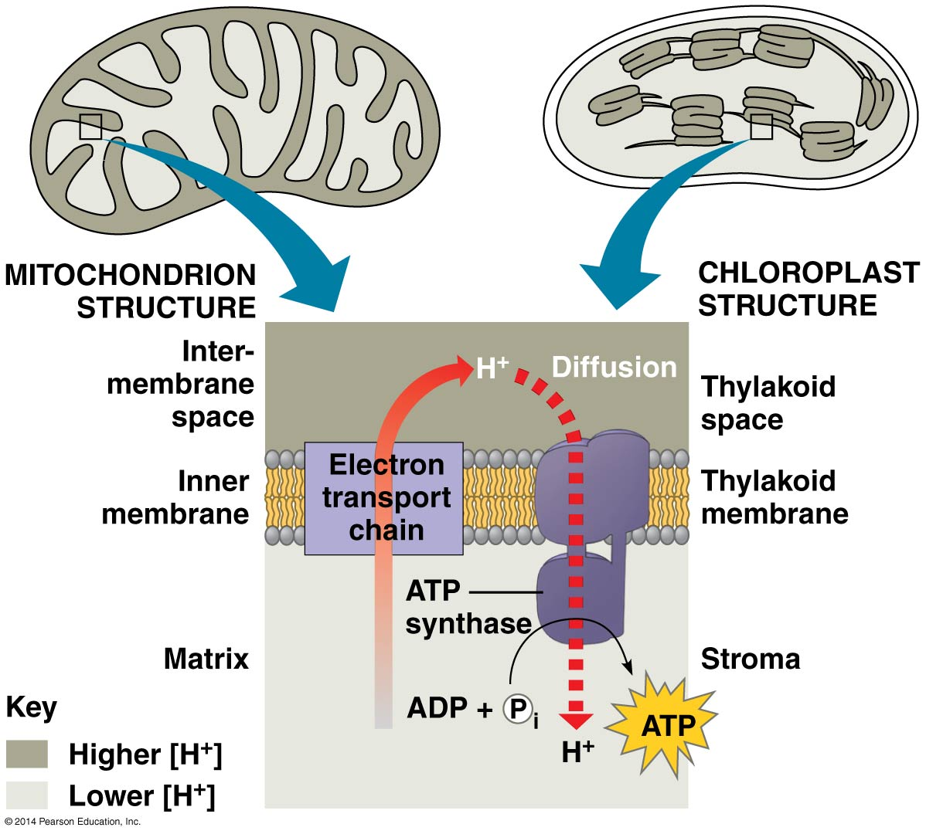
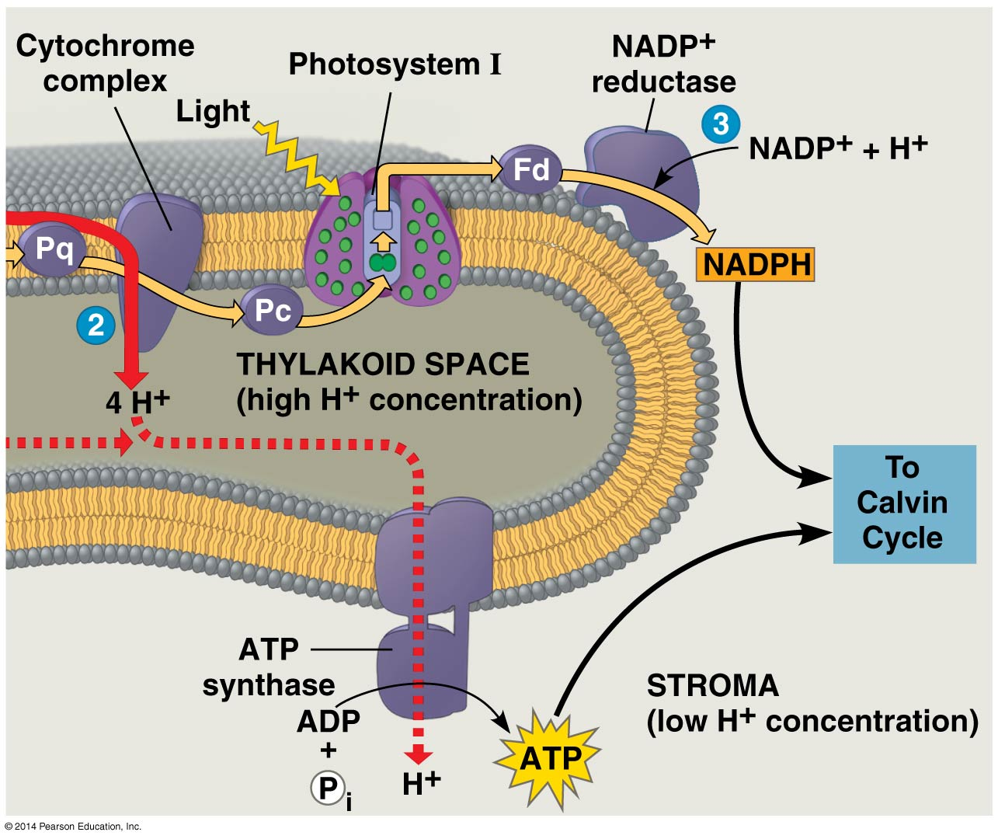
Calvin cycle – “Light independent” reaction
- Occurs in stroma. C enters as CO₂ via stomata.
- Sugar is produced by spending ATP and NADPH energy from light dependent reactions.
- Carbon fixation – incorporation of C into organic compounds.
- To net 1 G3P (glyceraldehydes 3-phosophate) molecule, Calvin cycle uses 9 ATP and 6 NADPH molecules. G3P becomes starting material for metabolic pathways that make other organic compounds.

Alternative mechanisms:
- Photorespiration – metabolic pathway that consumes O₂, releases CO₂, makes no ATP, and decreases photosynthetic output. NOT KNOWN if it’s beneficial to plants in any way. Thought to be relic of times when O₂ concentration low and CO₂ high. Occurs on hot, dry, bright days when stomata close and O₂ concentration in leaf exceeds that of CO₂.
- C₃ plants – first organic product of C fixation is 3-C compound, most plants like rice, wheat, soybeans. Rubisco is the primary enzyme
- C₄ plants – first organic product of C fixation is 4-C compound, found in several thousand species including sugarcane and corn. Uses unique leaf anatomy and PEP carboxylase instead of rubisco as primary enzyme. Because PEP carboxylase has higher affinity for CO₂, it is more efficient when CO₂ low. Mesophyll cells pump CO₂ into the bundle sheath. Thought to have evolved in hot, intense sunlight regions and thrive there today.
- CAM plants – crassulacean acid metabolism. Evolved in water-storing plants, including cacti and pineapples. Open stomata during night and close them during day, opposite of other plants. Incorporate CO₂ into a variety of organic acids (also 4C) synthesized into sugar during daylight.
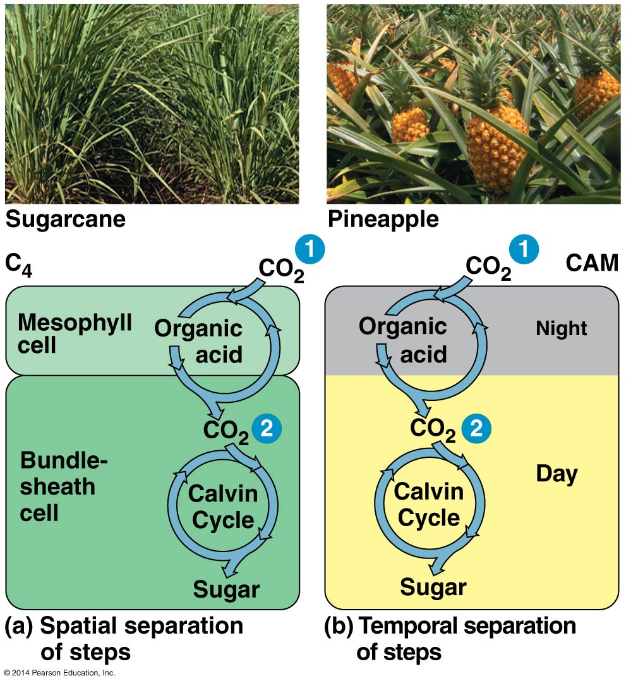
Factors that effect rate of photosynthesis:
- Light intensity - As light intensity increases, rate of increases and then levels off
- CO₂ levels - Increasing the level of CO₂ stimulates photosynthesis until the rate reaches a plateau
- Temperature - Raising the temperature accelerates reactions. The rate peaks at a certain temperature, and decreases when temperature is further increased
Fate of food made:
- ~50% of organic material is used as fuel for cellular respiration in plant cell
- Some products are lost to photorespiration
- Sucrose most common transport form in plant
- Proteins, lipids, and other products can be made from the sucrose
- Starch is energy storage form for plants – stored in chloroplasts, roots, tubers, seeds, and fruits
- Cell wall cellulose made of beta-glucose units
- Cellulose most abundant organic molecule on the surface of the planet
- Photosynthesis makes ~160 billion metric tons of carbohydrate/year (metric ton is 100 kg or ~1.1 tons)

