C22. Descent with Modification
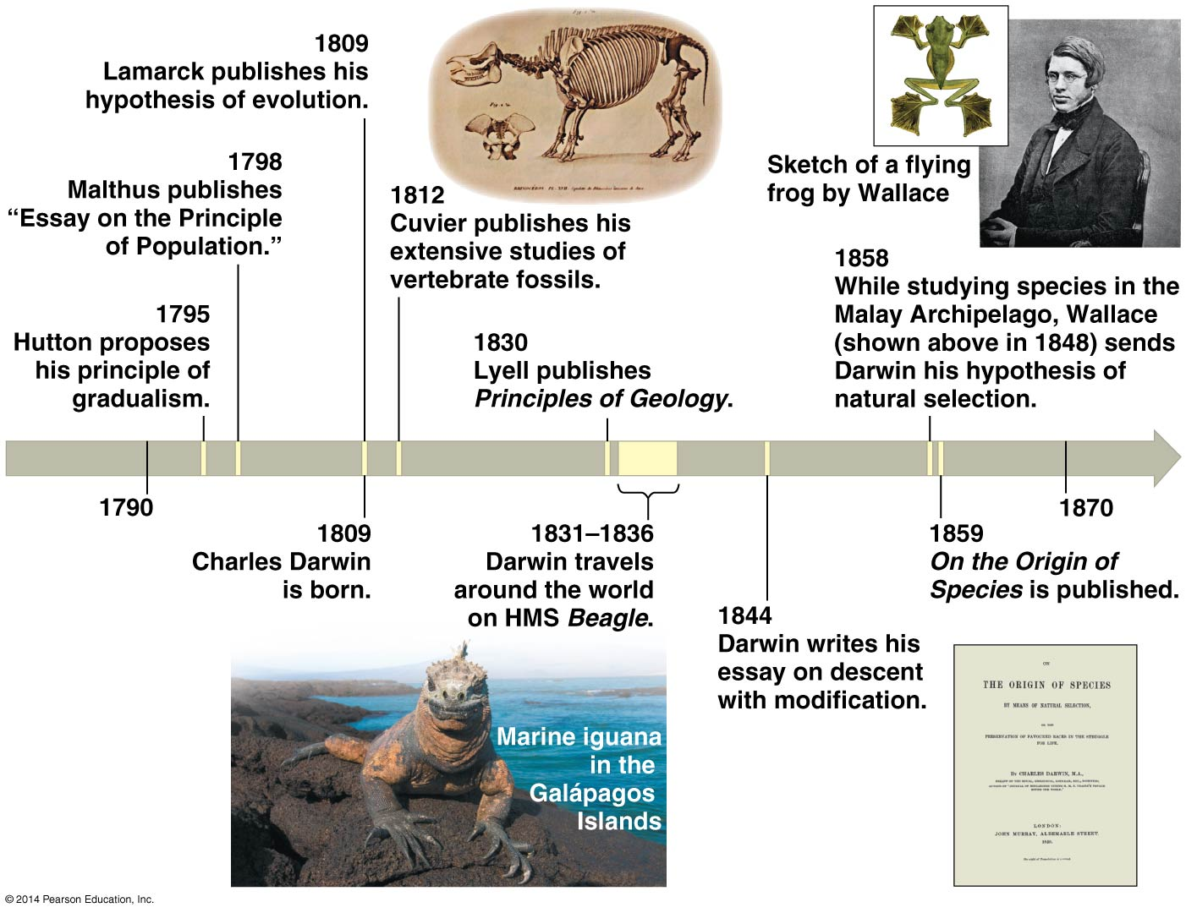

Evolution – changes in populations, species, or groups of species.

Microevolution – a change in the gene pool of a population from generation to generation.

Macroevolution – evolutionary change on a grand scale, encompassing the origin of new taxonomic groups, evolutionary trends, adaptive radiation, and mass extinction.

Natural selection – differential reproductive success (the unequal ability of individuals to survive and reproduce). NS occurs through an interaction between the environment and the organisms’ variability. The product of NS is adaptation to the environment (or death or movement of the population).

Artificial selection – the breeding of domesticated plants and animals.

Evidence of evolution:
- Fossil record – oldest known fossils are prokaryotes.
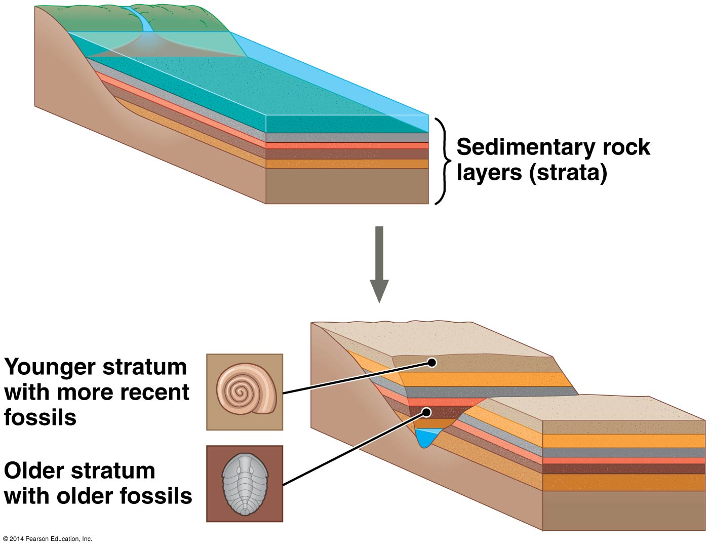
- Biogeography – the geographical distribution of species.
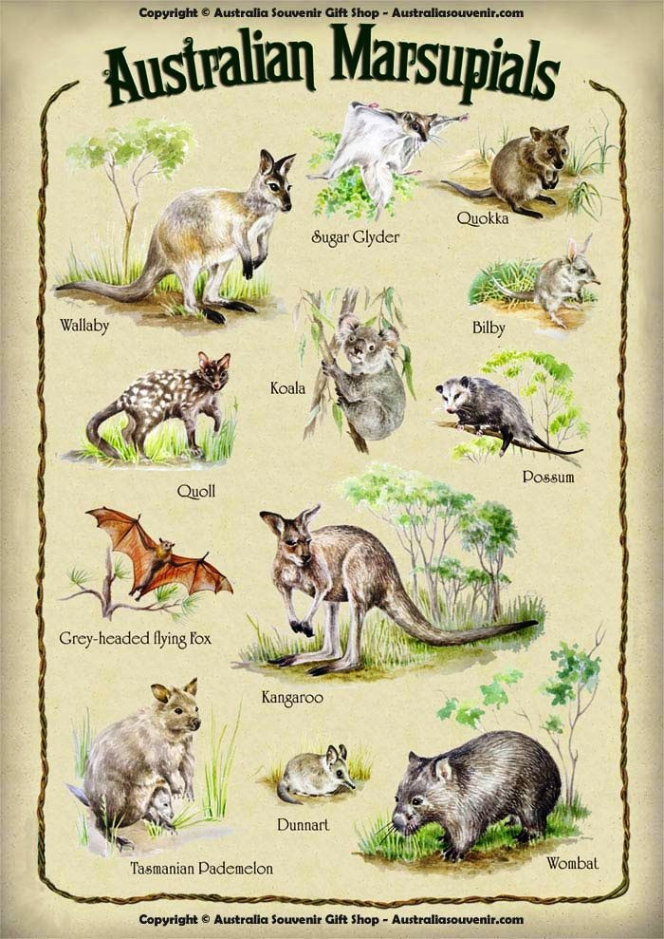
- Comparative anatomy
Homology – similarity in characteristics suggests common ancestors, homologous structures.
Vestigial organs or structures – structures of little or no importance to the organism.
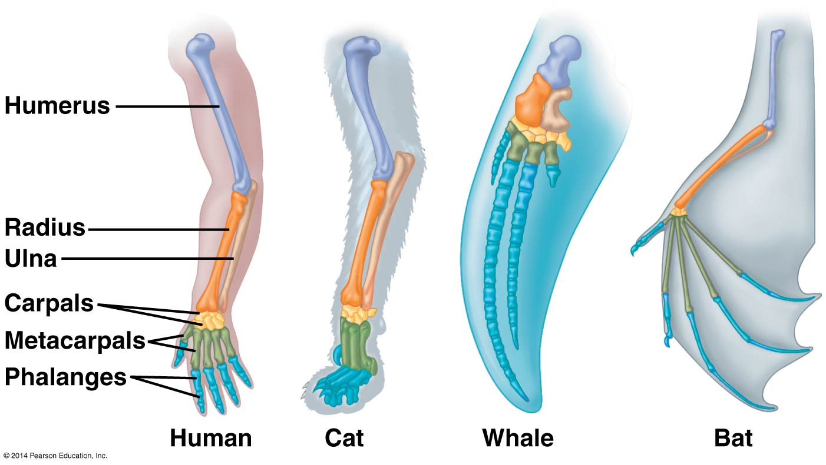
- Comparative embryology – closely related organisms go through similar stages in embryonic development.
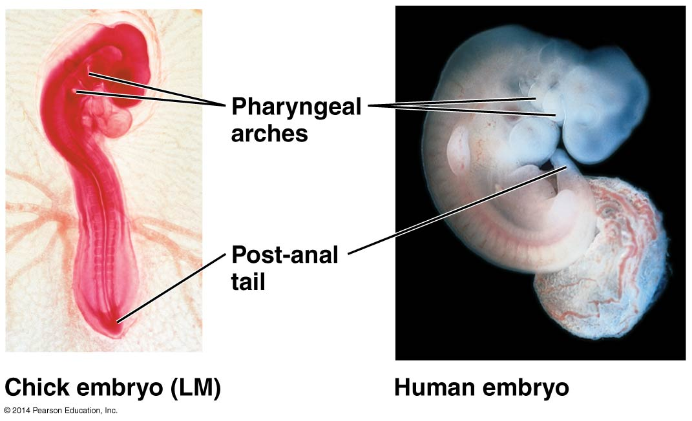
- Molecular biology – Proteins and DNA sequences are more similar in more closely related species. All living organisms use the same genetic code (ATCG).
- Population studies – Bacteria and pests reveal resistance to antimicrobials and pesticides.
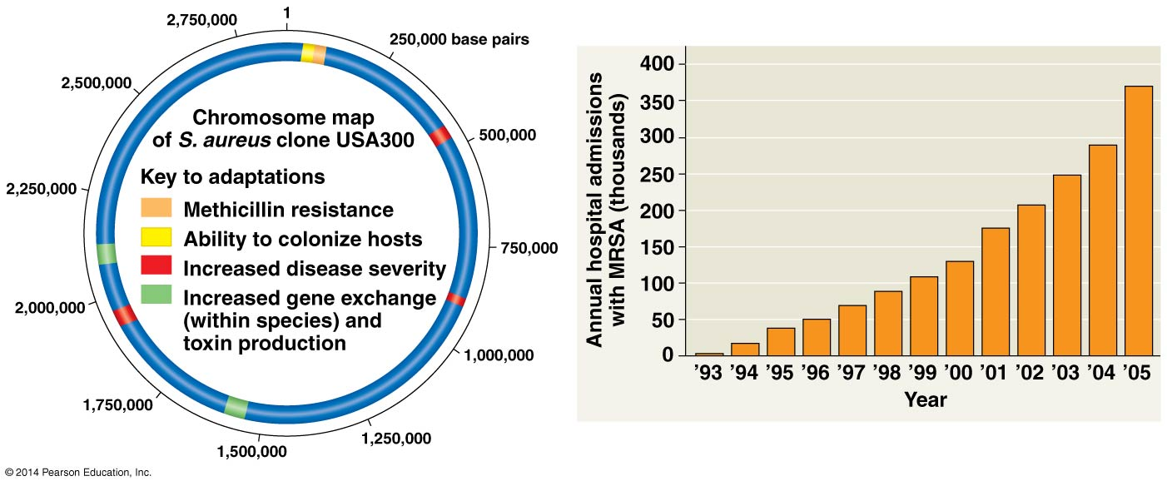

Phylogeny – evolutionary history of a species.

