C45. Hormones and the Endocrine System

Hormone – Molecule secreted into extracellular fluid, circulates and communicates regulatory messages to target cells. (Non-target cells lack receptors).

Endocrine system – regulates homeostasis, reproduction, development, energy metabolism, growth and behavior via hormones.

Endocrine glands – make hormones that go into surrounding fluid (like the pancreas secretes insulin).

Exocrine glands – secrete substances through ducts to the place they need to work (like salivary glands).

Neurohormones –molecules secreted by specialized neurons, travel into the bloodstream to reach target cells, ex. ADH (vasopressin).

3 classes of hormones:
Polypeptides, amines, and steroids
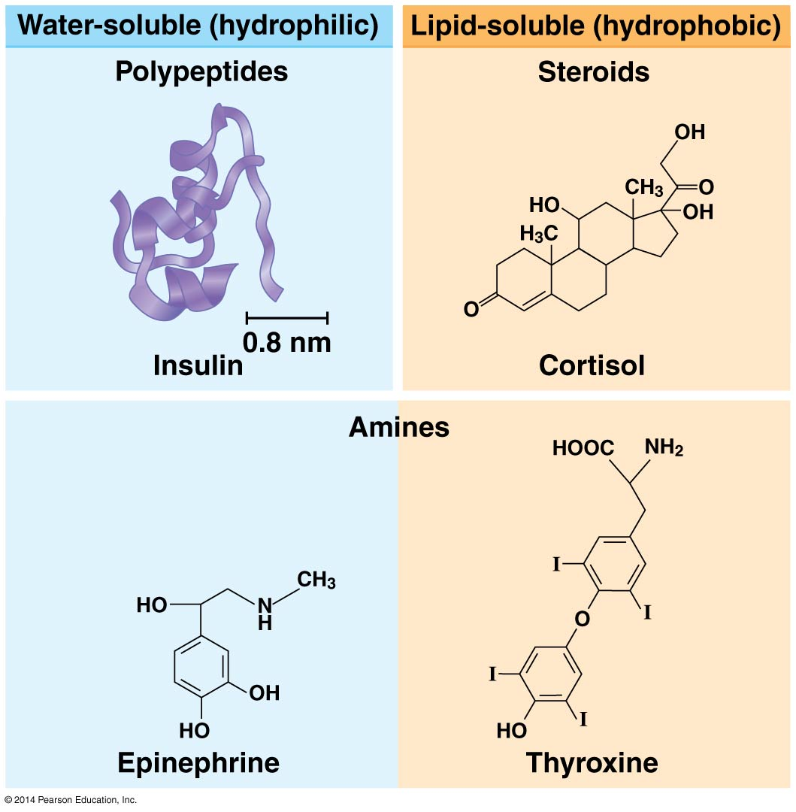
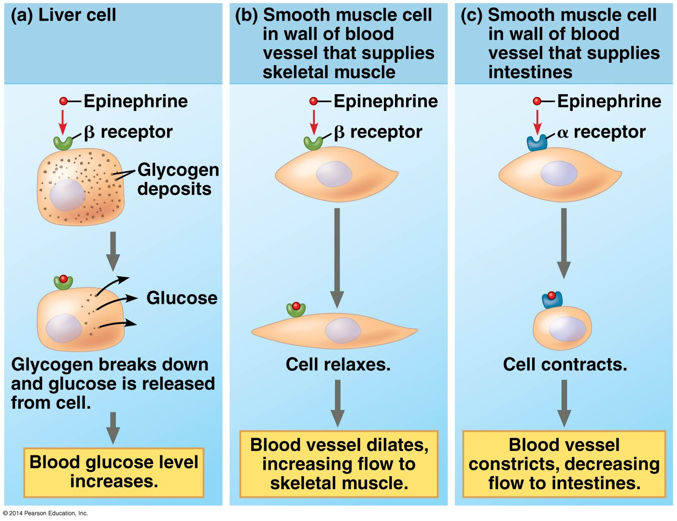

Nitric oxide (NO) – neurotransmitter and local regulator. When O₂ in blood falls, endothelial cells in blood vessel make it. It activates an enzyme that relaxes nearby smooth muscle cells, resulting in vasodilation; also produces erection in penis, Viagra sustains this by interfering with the breakdown of NO.

Prostaglandins – modified fatty acids with many functions such as helping induce labor. In immune system, promote fever, inflammation, and intensify pain.

Negative feedback and antagonistic hormone pairs help regulate homeostasis. Example, blood glucose kept constant by insulin and glucagon (made in the pancreas). Alpha cells make glucagon; beta cells make insulin. (The pancreas is an endocrine and an exocrine gland. For exocrine function it secretes bicarbonate ions and digestive enzymes in ducts that go into the small intestine).

Diabetes mellitus – refers to increased urination together with glucose in the urine.
Type 1 diabetes – insulin-dependent diabetes is an autoimmune disorder in which the beta cells have been destroyed so that no insulin is made. (Usually earlier onset).
Type 2 diabetes – non-insulin dependent diabetes (although some with it rely on insulin) usually due to the failure of target cells to respond to insulin. (Usually after age 40 – although the age keeps decreasing). Heredity is thought to play a stronger role in Type 2 diabetes. 90% of diabetics are Type 2. Type 2 is 7th most common cause of death in the US.

The endocrine and nervous systems work both individually and together in regulating physiology. Example, metamorphosis of caterpillar depends on brain production of prothoracicotropic hormone (PTTH), a peptide hormone, to stimulate glands behind the brain (prothoracic glands) to produce ecdysone, which promotes molting and final metamorphosis of the caterpillar into a butterfly.
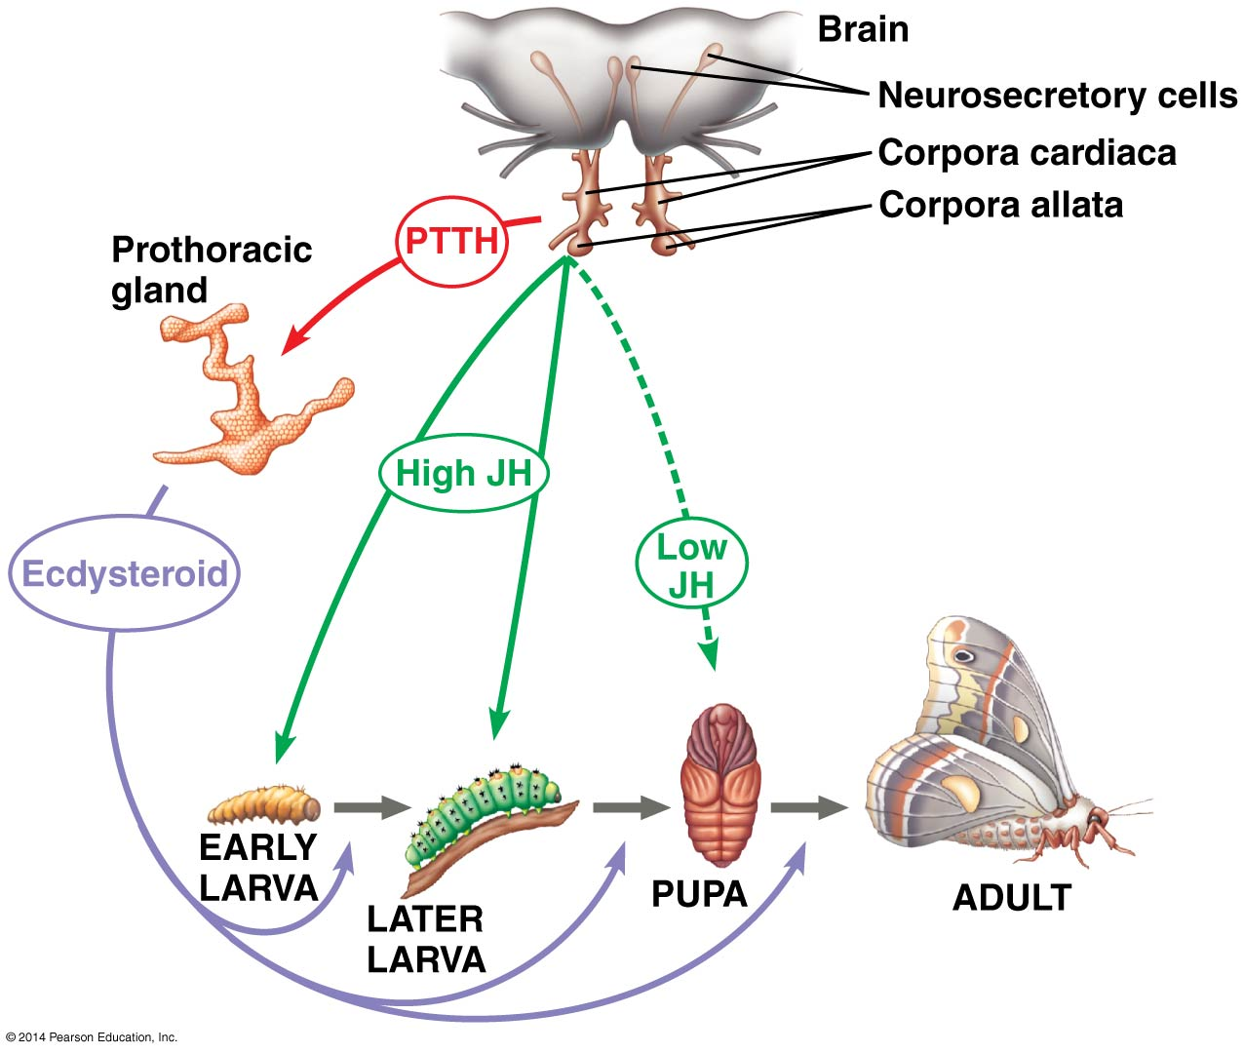
In vertebrates, the hypothalamus integrates the endocrine and nervous systems. For example, the brain relays sensory information about seasonal changes/mate availability to hypothalamus which in turn, regulates the release of reproductive hormones required for breeding.

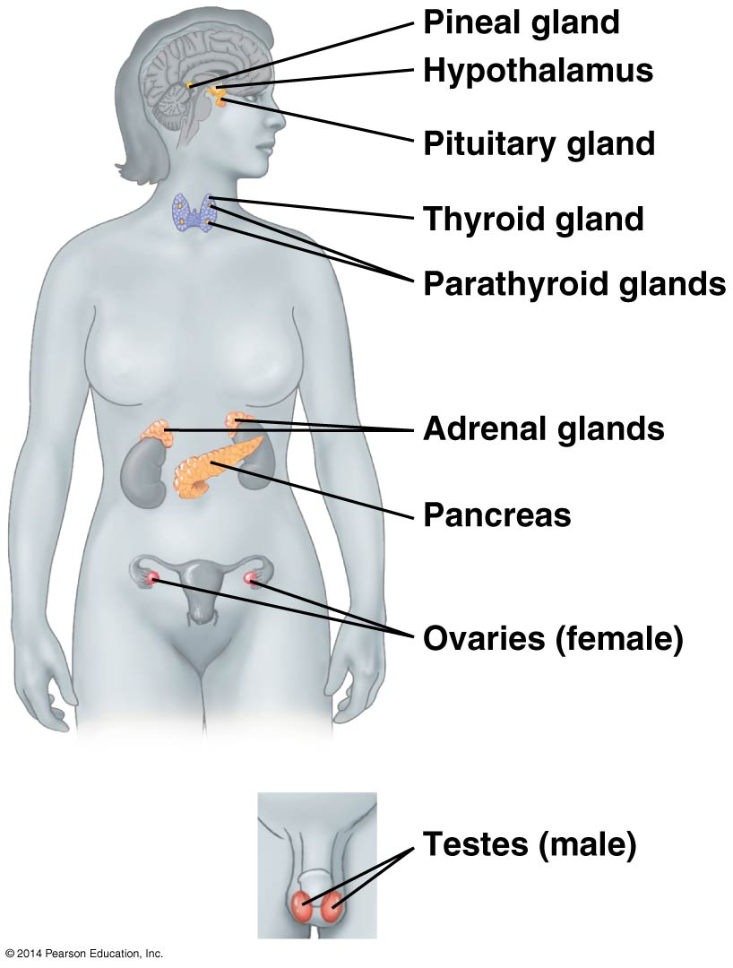
Signals from hypothalamus go to pituitary.
Posterior pituitary – stores and secretes 2 hormones made by the hypothalamus;
ADH – Antidiuretic hormone, promotes water retention.
Oxytocin – stimulates contraction of uterus and mammary gland cells.

Anterior pituitary – makes and releases these:
TSH -Thyroid stimulating hormone – stimulates thyroid gland.
FSH – Follicle stimulating hormone – stimulates ova and sperm production.
LH – Luteinizing hormone – stimulates ovaries and testes.
ACTH – adrenocorticotropic hormone – stimulates adrenal cortex to secrete glucocorticoids.
Prolactin – stimulates milk production and secretion.
MSH – melanocyte-stimulating hormone – regulates activity of pigment-containing cells in the skin of some amphibians, fish, reptiles.
GH – Growth hormone – stimulates growth (esp. bones) and metabolic functions.

Tropic hormone – regulates the function of endocrine cells or glands. (examples are FSH, LH, TSH, ACTH)

Thyroid gland makes triiodothyronine (T₃) and thyroxine (T₄) that regulate metabolism.
- Hyperthyroidism – leads to high body temperature, sweating, weight loss, irritability, high blood pressure. Most common type is Grave’s disease.
- Hypothyroidism – leads to weight gain, lethargy, and intolerance to cold.

Control of Blood Calcium
Parathyroid glands produce parathyroid hormone (PTH) when Ca²⁺ falls below set point. (Ca²⁺ too low causes muscle contraction, too high causes organ damage). PTH releases Ca²⁺ from the bone, stimulates reabsorption of Ca²⁺ in kidney, makes vitamin D which then works on intestine to absorb more Ca²⁺.
Thyroid gland releases calcitonin if Ca²⁺ rises above set point. Calcitonin inhibits bone resorption and enhances Ca²⁺ release by the kidney. In humans calcitonin not used except during extensive bone growth of childhood.

Adrenal medulla: (fight or flight/stress hormones stimulated by nervous system)
Catecholamines – class of amine hormones made from tyrosine.
Epinephrine (adrenaline) and norepinephrine (noradrenaline) increase glycogen breakdown (for energy), stimulate release of fatty acids from fat cells, increase heart rate, stroke volume, and dilate the bronchioles in lungs, alter blood flow away from skin and digestive organs. Epinephrine has stronger effect on heart and metabolic rates, norepinephrine modulates blood pressure more.

Adrenal cortex: (stress hormones stimulated by endocrine signals)
Stress causes hypothalamus to release ACTH which causes adrenal cortex to release:
Glucocorticoids – stimulate making of glucose from non-carbohydrate sources such as proteins, ex. Cortisol breaks down muscle protein for fuel. Also, have anti-inflammatory properties.
Mineralocorticoids – maintain salt and water balance, ex. Aldosterone triggered by low blood pressure retains Na⁺ and water.
Small quantities of sex hormones made in adrenal cortex, such as testosterone. Thought to increase sex drive in women; not well understood.

Gonadal Sex Hormones
The testes primarily make androgens such as testosterone which determines maleness in utero and secondary male sex characteristics.(See page 1010, figure 46.13).
Ovaries make estrogens, like estradiol, which stimulate uterine lining growth, promote development and maintenance of female secondary sex characteristics. Progestins, like progesterone, also promote uterine lining growth. (See Figure 46.14, page 1011, for female hormone interactions).

Pineal gland (in the brain) makes melatonin which contains light sensitive cells or has nervous system connections from the eyes that control its secretory activity. Melatonin affects skin pigmentation in many vertebrates, but primarily controls biological rhythms associated with reproduction. Melatonin is secreted at night; longer nights produce more. Melatonin targets the suprachiasmatic nucleus (SCN) which works like a biological clock. Melatonin decreases SCN activity.

