C53 Population Ecology
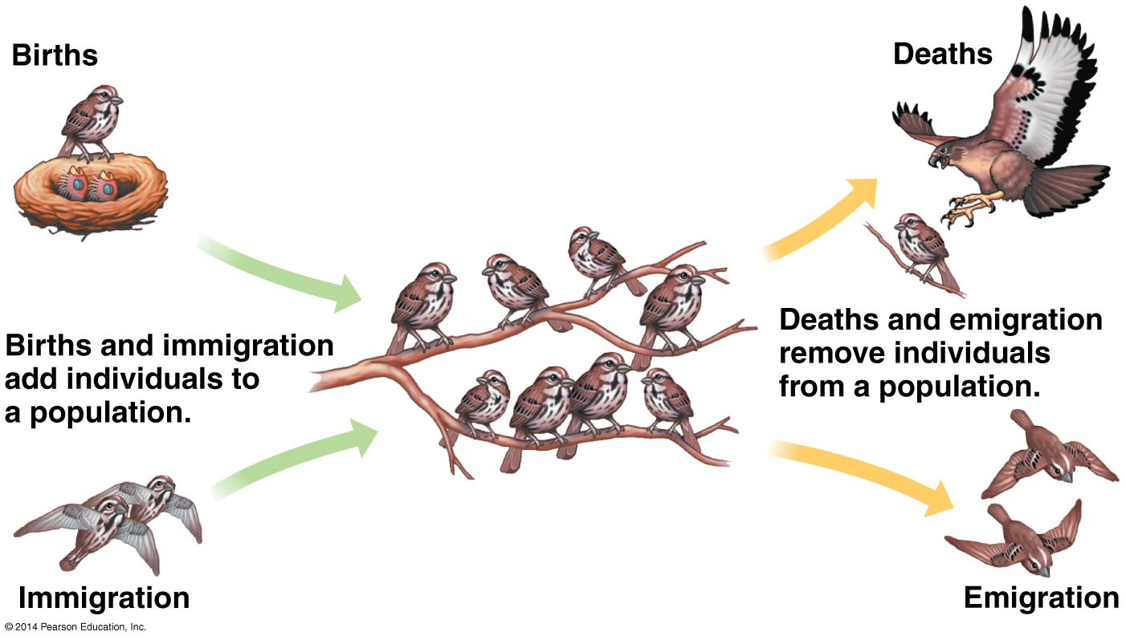
Essential knowledge: Communities are composed of populations of organisms that interact in complex ways.
Population characteristics:
- Density – number of individuals per unit area or volume. (Mark-recapture method used to determine this sometimes).
- Dispersion – the pattern of spacing among individuals within the boundaries of the population. (clumped, uniform, or random)
- Demographics – vital statistics and how they change, such as birth and death rates.
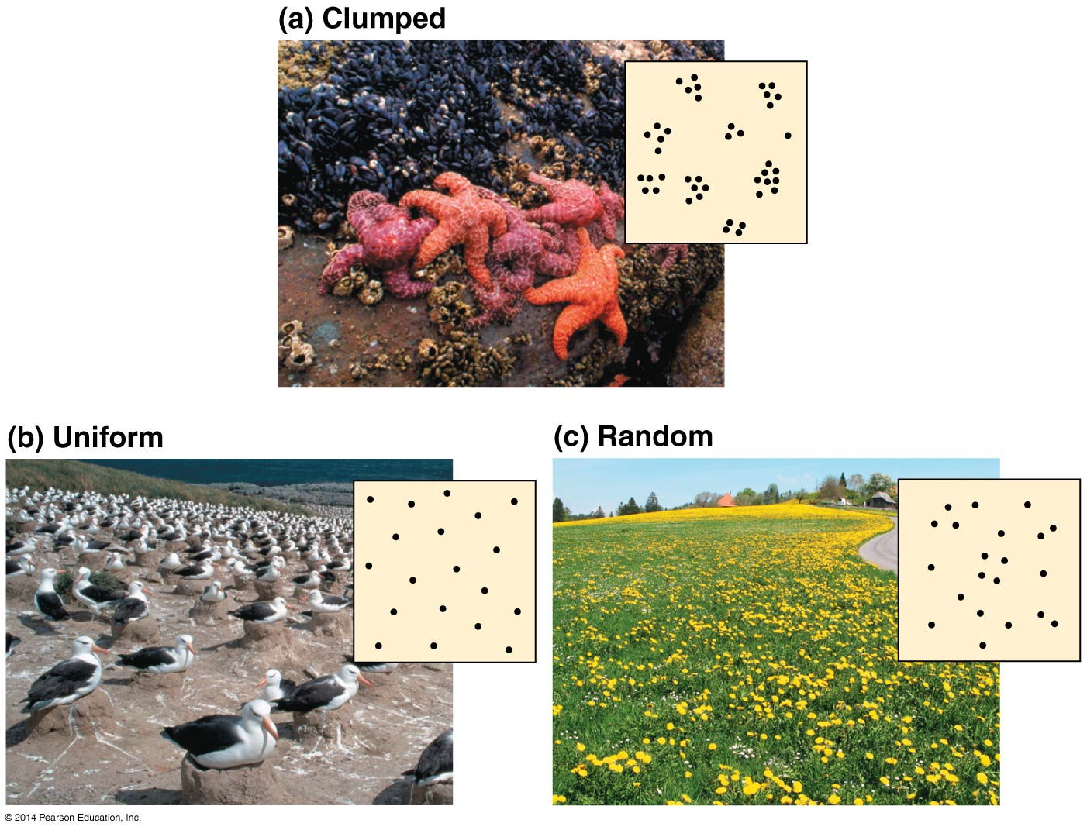
Life history – traits that affect an organism’s schedule of reproduction and survival. Two common patterns (although some fall in between): depend on survival rate of offspring and if adult will survive to reproduce again.
- Big-bang reproduction – one time (usually at end of life), ex. Agave desert plant or salmon.
- Repeated reproduction – throughout adulthood.
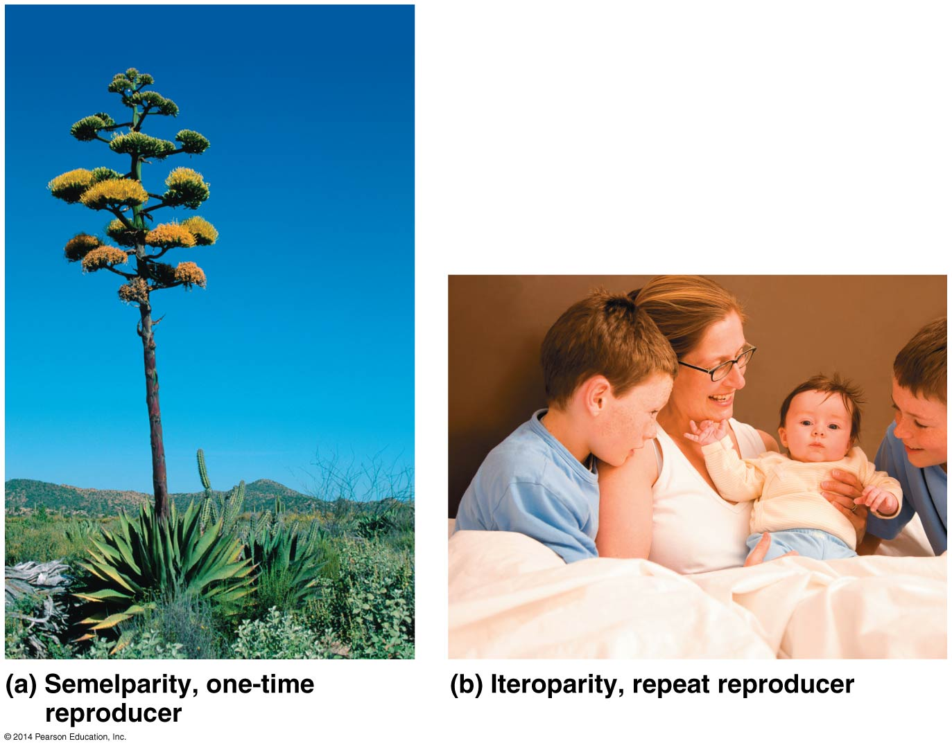
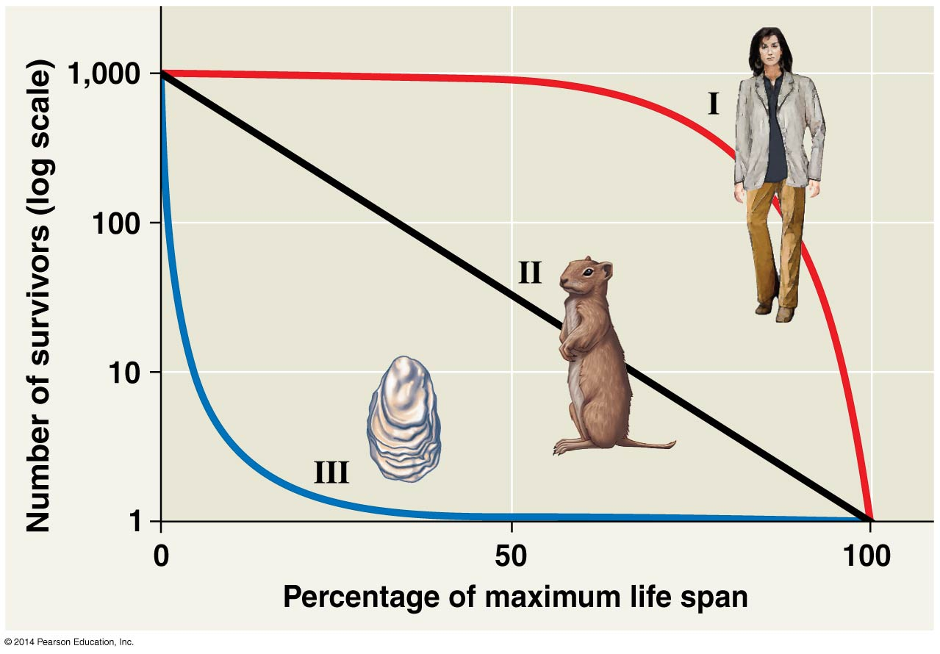

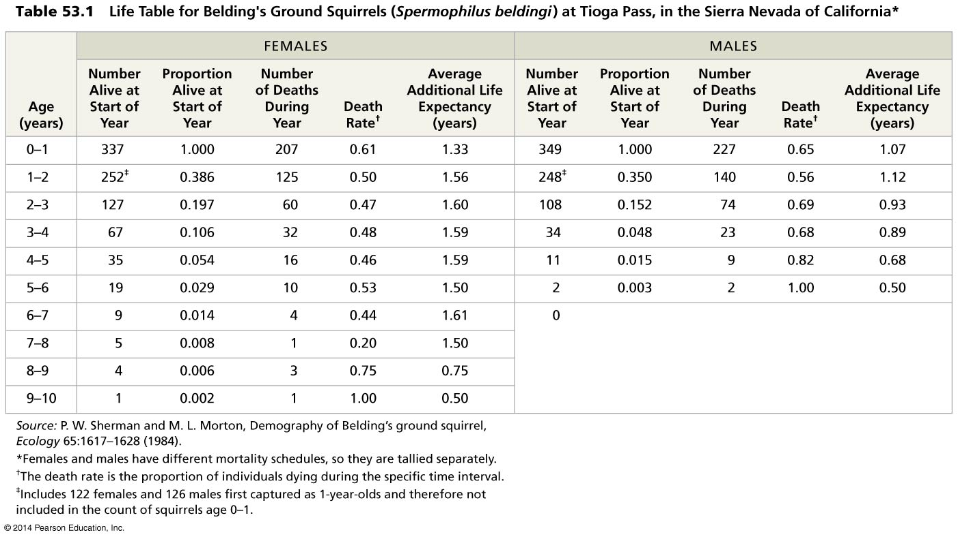
Exponential growth – J curve, rapid growth, no limiting factors expressed by dN/dt = r_{max}N where d is the per capita death rate, t is time, r_{max} is the maximum per capita and N is the number of individuals in the population.
Logistic growth model – S curve as a result of limiting factors, dN/dt = r_{max}N(K-N)/K where K is carrying capacity.
Carrying capacity – maximum population size a particular environment can sustain.
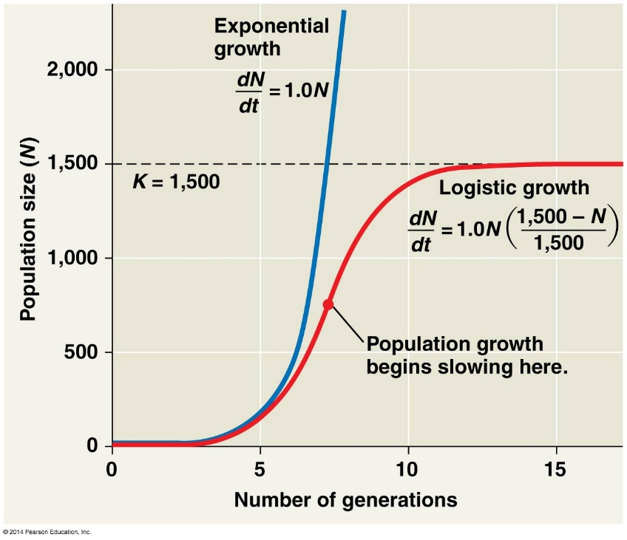
K-selection – (stable environments) selects for life history traits sensitive to population density, ex. Mature trees growing in an old-growth forest, humans, elephants.
r-selection – (unstable environments) selects for life history traits that maximize success in low densities, ex. Bacteria, insects, weeds, rodents.
Density independent – birth rate or death rate does not change with population density. Ex. Floods, earth quakes.
Density dependent – death rate rises as population density increases. Examples of factors: Competition for resources, territoriality, disease, predation, accumulation of toxic wastes, intrinsic factors like stress.
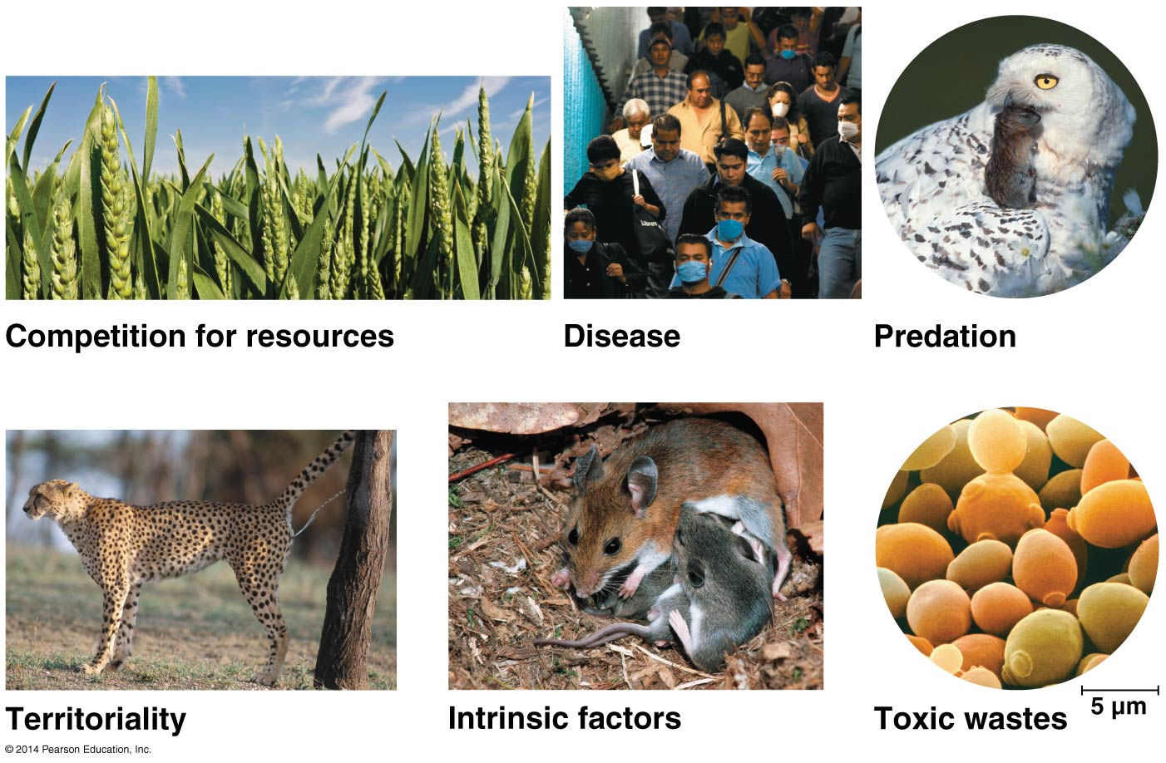
Predator/prey relationships – dependency on each other, Ex. Wolves and moose
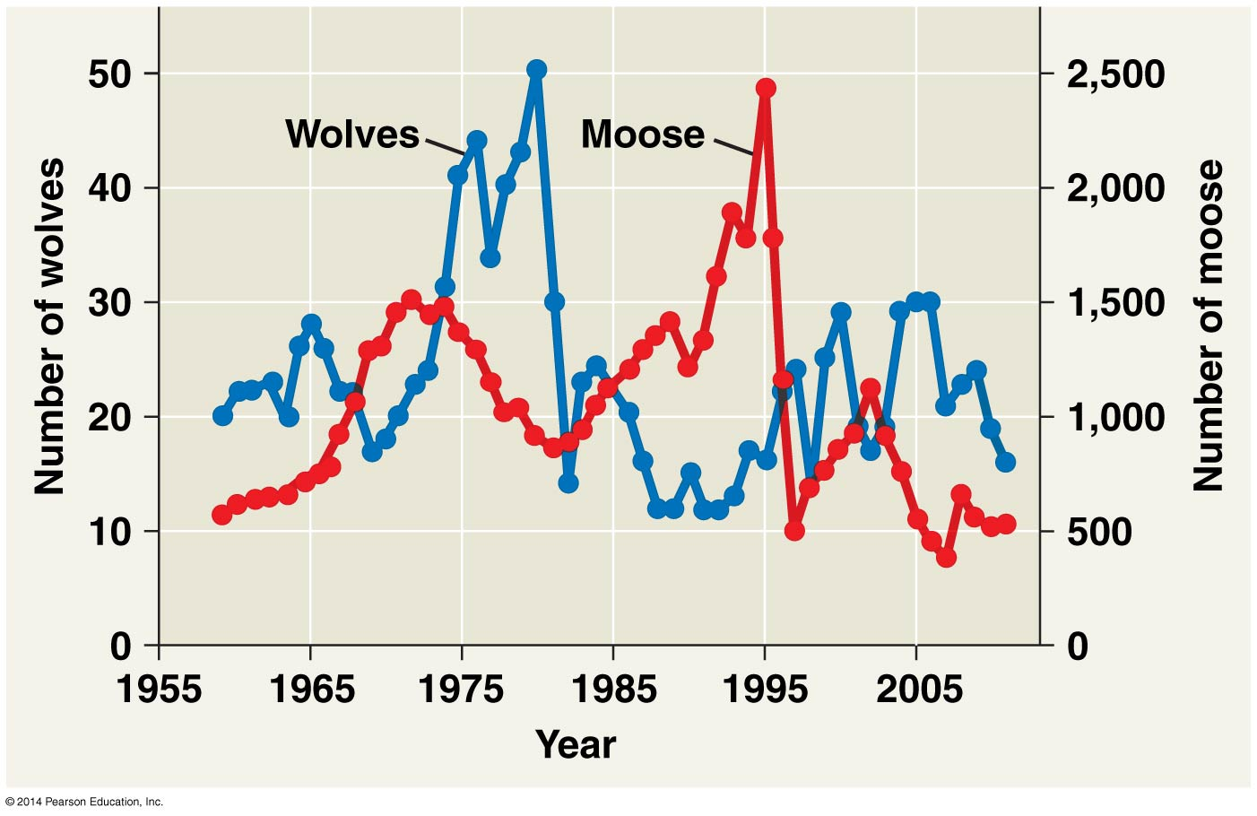
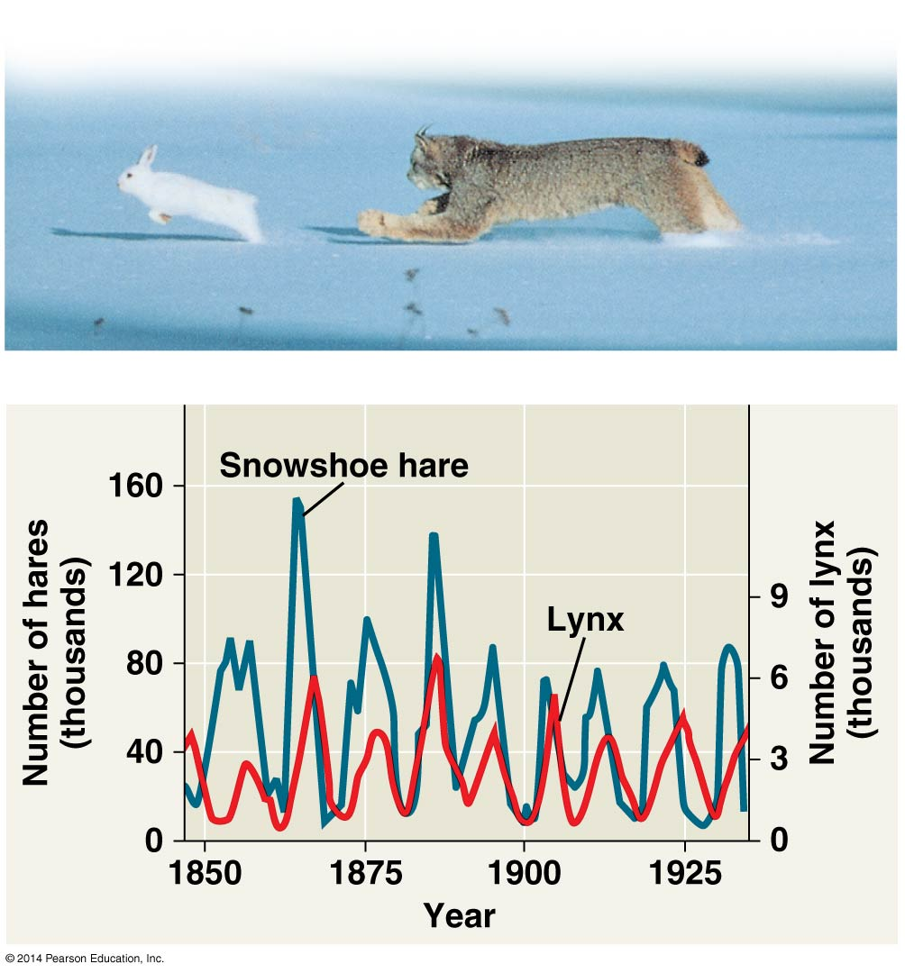
Human population:
- Demographic transition – a shift from rapid population growth in which birth rate outpaces death rate to zero population growth characterized by low birth and death rates.
- Age structure pyramids – age groups with gender. Be able to recognize shapes: rapid growth, stable, and declining.
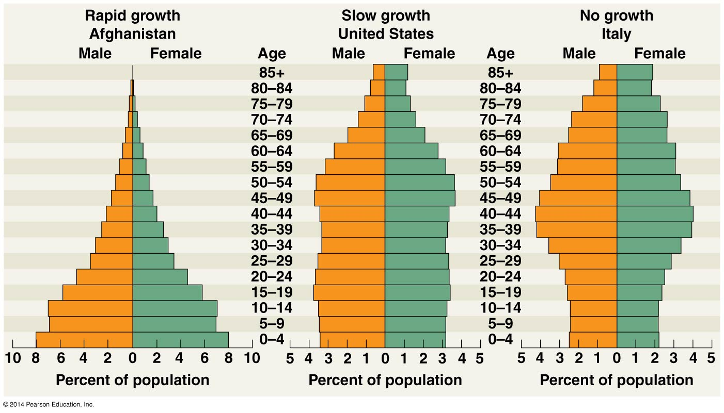
- Infant mortality – number of infant deaths per 1,000 live births.
- Life expectancy at birth – predicted average length of life at birth. Varies widely, ex. In Angola in 2005 life expectancy was 39 years, about half that in Japan, Sweden, Italy, and Spain.
- Global carrying capacity? Human population is no longer growing exponentially but is still increasing rapidly. (Change thought due to diseases, including AIDS, and to voluntary population control).
