C7 Membranes Video

Membranes:
- Held together mostly by hydrophobic interactions
- Most lipids and some proteins drift randomly in the plane of the membrane
- Rarely flip-flop from one side to the other
- Must be fluid to work properly
- Fluid mosaic model – arrangement of phospholipid layer(s) with proteins immersed throughout
- For different functions, membranes differ in composition
- In animals, cholesterol helps stabilize membrane by restraining movement of phospholipids and lowers temperature required for membrane to solidify
- Selective permeability – some substances cross more easily than others
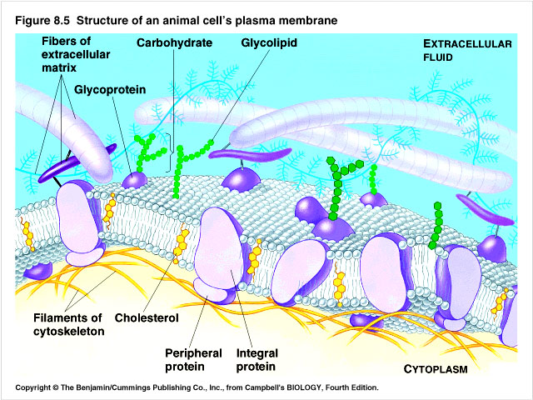

Amphipathic – molecule with a hydrophilic region and a hydrophobic region

Plasma membrane:
- Integral proteins – transmembrane proteins with hydrophobic regions consisting of stretches of nonpolar amino acids, usu. coiled in alpha-helices
- Peripheral proteins – appendages loosely bound to the membrane surface often to integral proteins
- Membrane protein functions:
- Transport
- Enzymatic activity
- Signal transduction
- Intercellular joining
- Cell-cell recognition, oligosaccharides or glycoproteins as tags
- Attachment to cytoskeleton or ECM
  - ER makes the plasma membrane
  - Transport proteins:
- Channel proteins have hydrophilic channels for specific ions and polar molecules, some are gated
- Carrier proteins bind to specific passengers and move them across, ex. glucose enters liver cells but not fructose (isomer)

Passive transport – no energy used
- Diffusion – particles move from high concentration to low
- Dynamic equilibrium – concentration gradient = 0; movement continues, but no net movement
- Osmosis – diffusion of water; water moves from hypotonic to hypertonic or from higher water potential to lower
- Hypertonic – solution with higher concentration of solutes
- Hypotonic – solution with lower concentration of solutes
- Isotonic – solutions with equal solute concentrations
- Plant cell terms:
  - Turgid – very firm, when plant has much water
  - Flaccid – limp, plant cell wilts due to water loss
  - Plasmolysis – damaging phenomenon when in hypertonic conditions, plasma membrane pulls away from cell wall (bacteria and fungi also experience this)
- Facilitated diffusion – diffusion using channel proteins

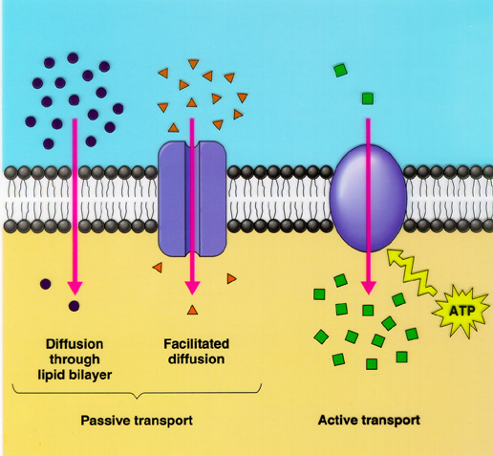

Active transport – energy used, ATP; cell pumps particles against the concentration gradient.

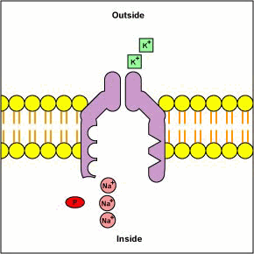

- Electrogenic pump – transport protein that generates voltage across a membrane, ex. Na-K pump which exchanges 3 Na⁺ for 2 K⁺ is major electrogenic pump of animal cells. Proton pump is main electrogenic pump of plants, bacteria, and fungi which actively transports H⁺ out of cell. By generating voltage across membranes, electrogenic pumps store energy that can be used for cellular work.
  - Membrane potential – voltage across a membrane, -50 - -200 mv, voltage is electrical potential energy. Cytoplasm negative compared to extracellular fluid. Membrane acts like a battery, favoring transport of cations into and anions out of the cell.
  - Electrochemical gradient – combined electrical and chemical forces acting on the plasma membrane. Co-transport – when the “uphill” transport substance, comes across partnered with another substance, ex. H⁺ and sucrose.
- Exocytosis – secretion of macromolecules from vesicles temporarily fused with plasma membrane
- Endocytosis – taking in macromolecules by forming a new vesicle from the plasma membrane
  - Phagocytosis – engulfing particles
  - Pinocytosis – engulfing liquids
  - Receptor-mediated endocytosis – engulfing of specific substances that bind to ligands (protein receptor sites) ex. cholesterol taken into some cells this way

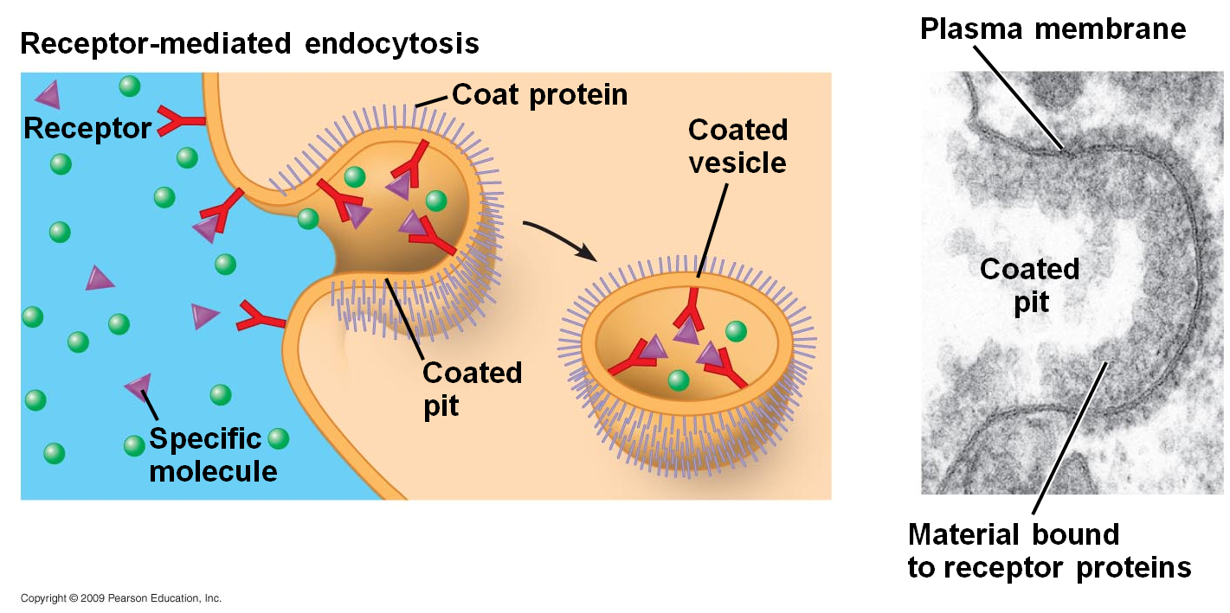
Vesicles also renew the plasma membrane in addition to transport work.

