Chapter 54: Community Ecology (Theme: Factors affecting biodiversity)

Community – group of populations of different species living close enough to interact.

Interspecific interaction – relationship between 2 or more species, examples are competition, predation, herbivory, and symbiosis (mutualism, parasitism, & commensalism).
Interspecific competition – (-/-) different species compete for same resources, ex. Weeds and garden plants compete for soil nutrients and water.
- Competitive exclusion – elimination of the inferior competitor.
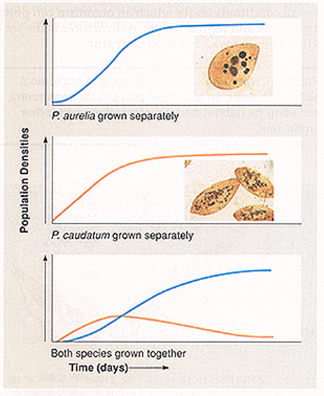
- Ecological niche – the sum of a species’ use of biotic and abiotic resources, the organism’s role, ex. For tree lizard, includes temperature range, size of branches it perches on, time of day it’s active, sizes and kinds of insects it eats…
- Resource partitioning – the differentiation of niches that enables similar species to coexist in a community.

- 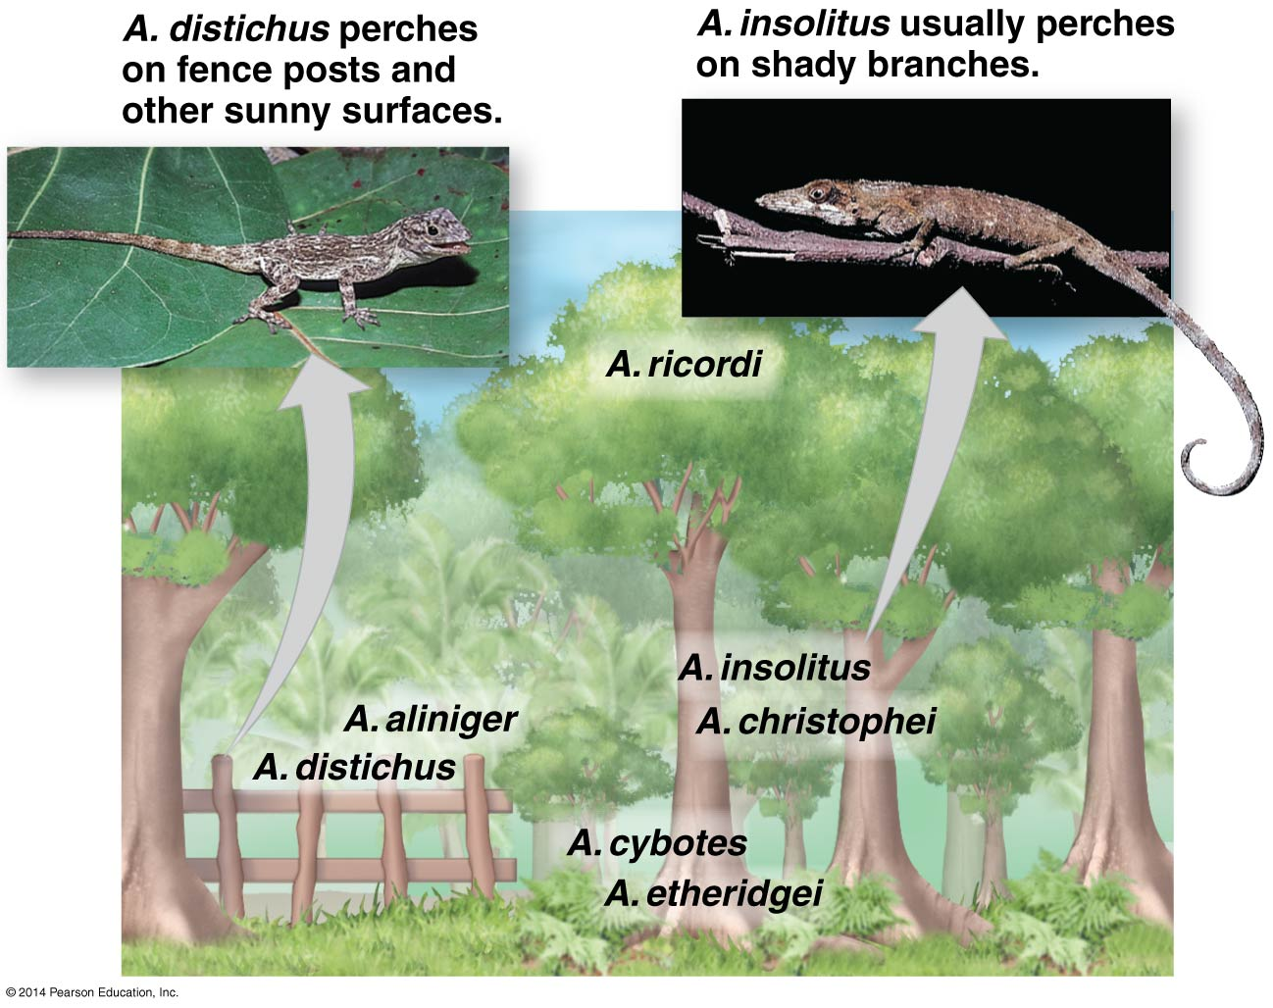
- Character displacement – tendency for characteristics to diverge more in sympatric populations of 2 species than in allopatric populations, (indirect evidence of past competition).
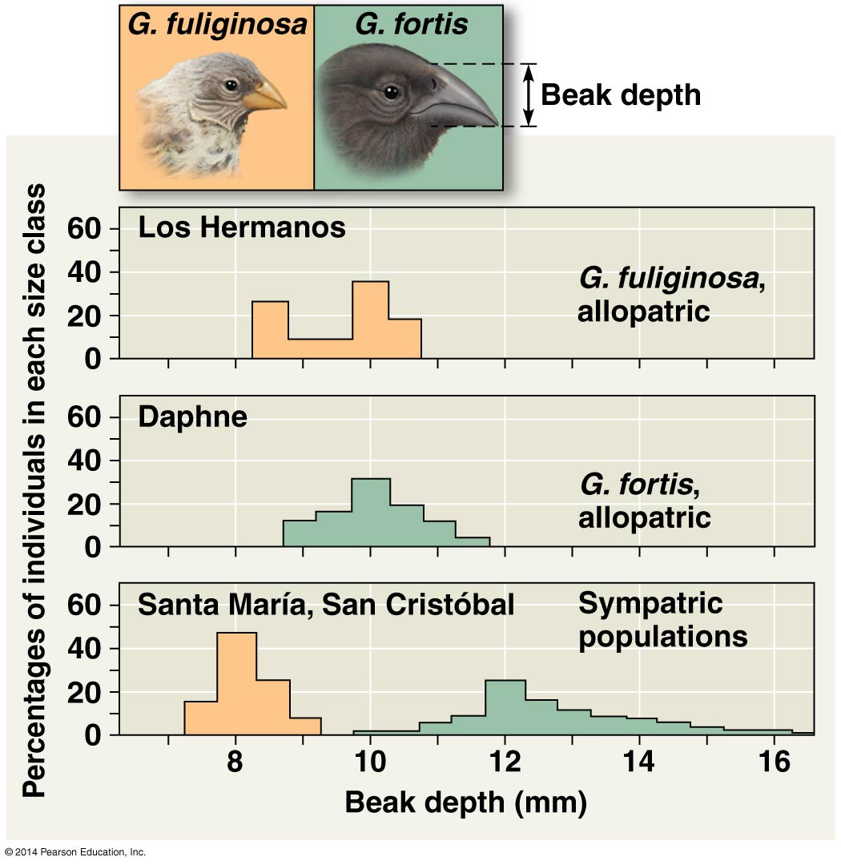
Predation – (+/-) the predator kills and eats the other, the prey. (Diversity seen in predators as well as prey for this struggle for survival).
- Cryptic coloration – camouflage.
- Aposematic coloration – warning coloration, ex. Posion dart frog.
- Batesian mimicry – harmless or palatable looks like harmful or unpalatable.
- Mullerian mimicry – 2 or more unpalatable species resemble each other, presumably each species gains advantage because the more there are, the more quickly predators avoid any prey with that appearance.
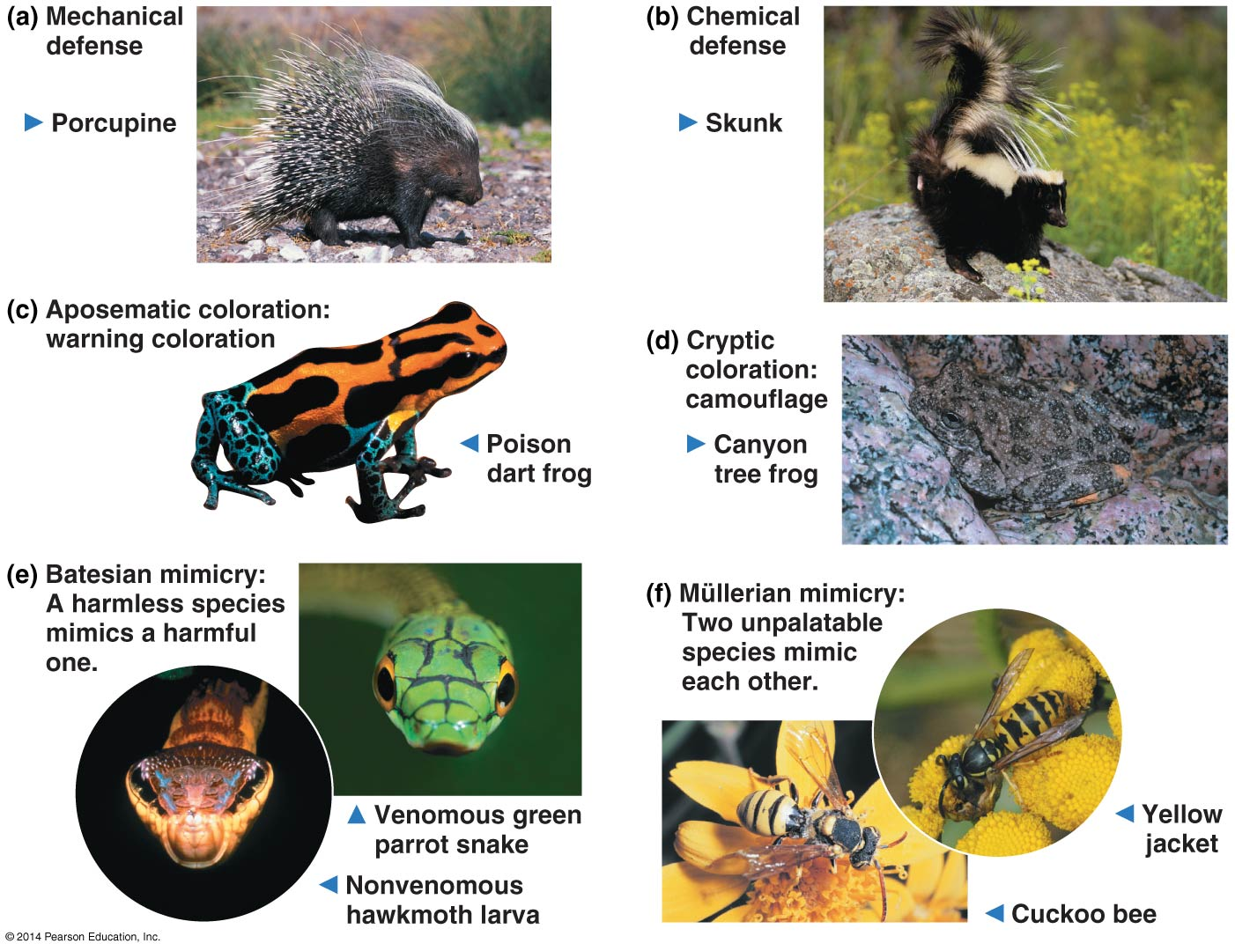
Herbivory – (+/-) organism eats parts of a plant or alga. Plants can’t run, thus use toxins, spines, or thorns.

Symbiosis – 2 or more species live in direct and intimate contact.
- Parasitism – (+/-) Parasite gets nourishment from host. Endoparasites, like tapeworms, live inside their host. Ectoparasites, like ticks, live outside their host.
- Mutualism – (+/+) benefits both species, ex. Nitrogen fixation by bacteria in the root nodules of legumes, digestion of cellulose by some herbivores like cattle, mycorrhizae – associations of plant roots with fungi.
- Commensalism – (+/0) one benefits and the other is not helped or harmed, ex. Barnacles on whales.

Species diversity – variety of different kinds of organisms in a community.
- Species richness – number of different species in a community.
- Relative abundance – proportion each species represents of all individuals in the community.
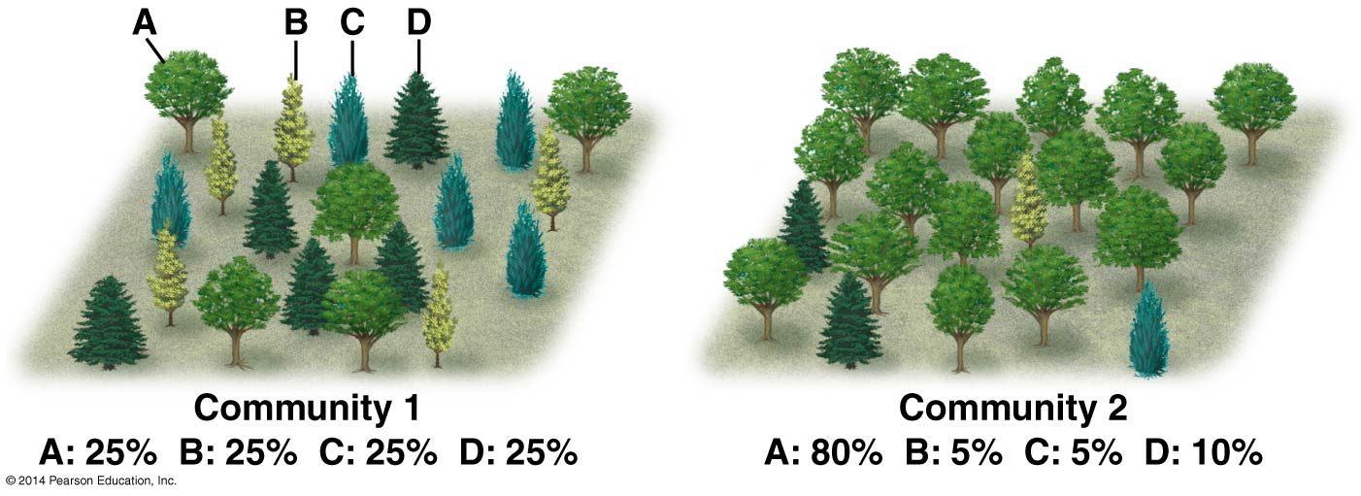
Trophic structure – feeding relationships between organisms.
- Food chain – 3-5 steps following one path of the food web. (rarely 6-8)
- Food web – diagram with arrows linking feeding relationships in the community.
- Why food chains are short:
  - Energetic hypothesis – limited by inefficiency of energy transfer; only 10% of energy stored in organic matter is converted to organic matter at the next trophic level, ex. 100 kg of plants can support 10 kg of herbivores. Biomass – total mass of all individuals in a population.
  - Dynamic stability hypothesis – long food chains are less stable than short chains, thus food chains should be shorter in unpredictable environments. (The longer a food chain is, the more slowly top predators can recover from environmental setbacks).

Dominant species - most abundant species in a community. Ex, American chestnut tree was dominant in eastern deciduous forests before 1910 (>40% of mature trees). Humans accidentally introduced fungal disease, chestnut blight, to NY from Asia . Between 1910 & 1950 all killed. Other trees replaced but we lost 7 species of moths and butterflies that fed on the tree.

Invasive species – exotics, outside their native range.

Keystone species – exert strong control on the community by their pivotal roles or niches. (Identified by removal experiments), ex. Sea otter keystone to sea urchin and kelp density.

Foundation species – ecosystem engineers, ex. Beaver.

Facilitators – species with a positive effect on the community.
Bottom-up model – a unidirectional influence from lower to higher trophic levels.

Top-down model – a unidirectional influence from higher to lower trophic levels.

Biomanipulation – uses the top-down model to alter the density of the higher level consumers in lakes instead of using chemical treatments to combat algal blooms.

Disturbance - an event, such as a storm, fire, flood, drought, overgrazing, or human activity, that changes a community by removing organisms from it or altering resource availability.

Intermediate disturbance hypothesis – moderate levels of disturbance can create conditions that increase species diversity. Low levels keep status quo (promote more of the same) while high levels of disturbance exceed the tolerances of most organisms. Supported by both aquatic and terrestrial studies. Frequent natural fires normal. When prevented, fuels build up and then a very severe fire destroys many species.
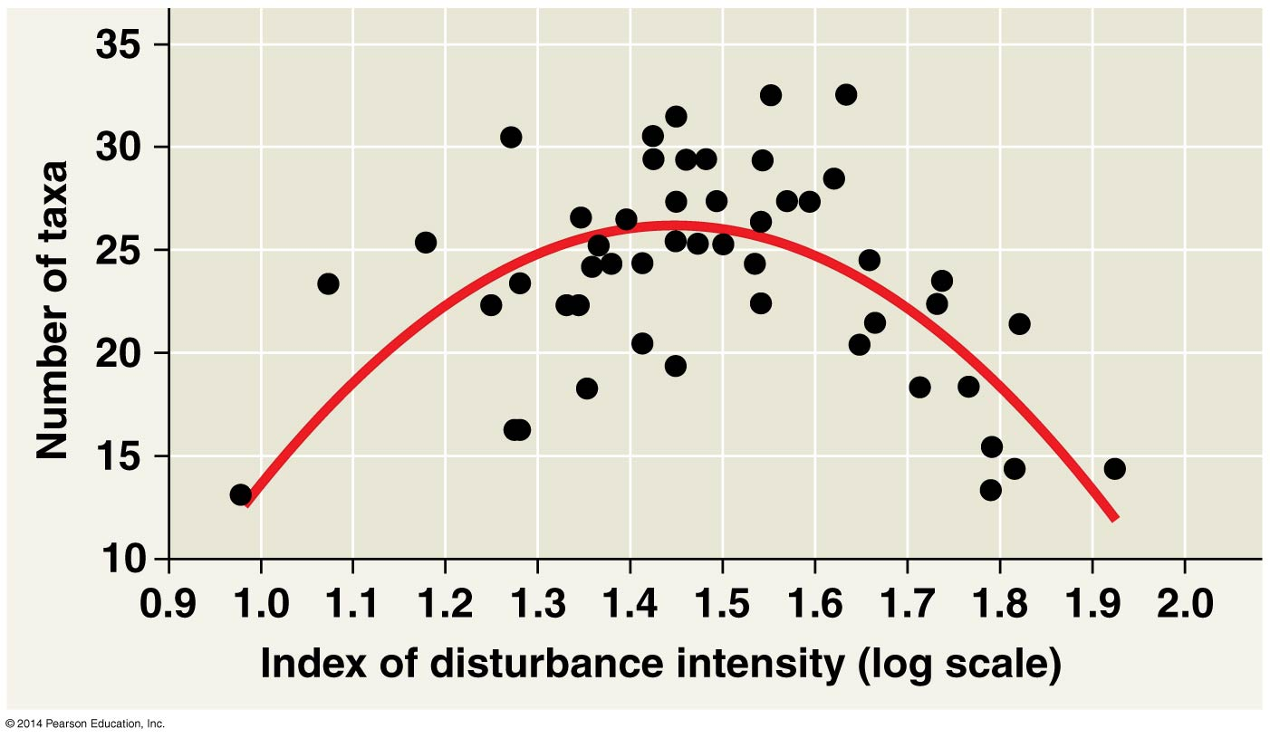
Ecological succession – the establishment of a community in an area virtually barren of life.
- Primary succession – succession wherein soil has not yet formed, ex. New volcanic island or retreating glacier. Pioneer species – first organisms that settle in, ex. Lichen usually have properties that allow others to follow. 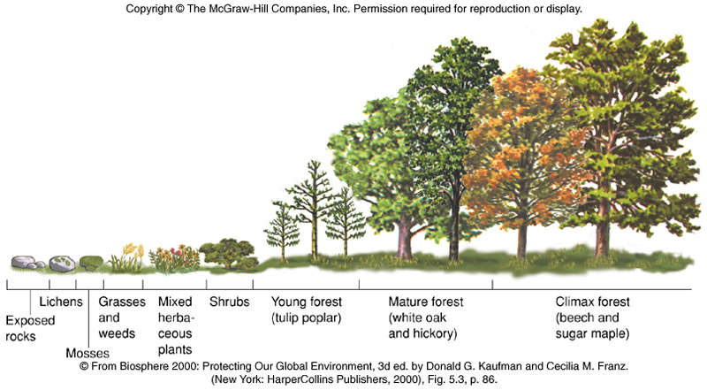
- Secondary succession – transition wherein a community has been cleared, but soil is intact, ex. Fire. 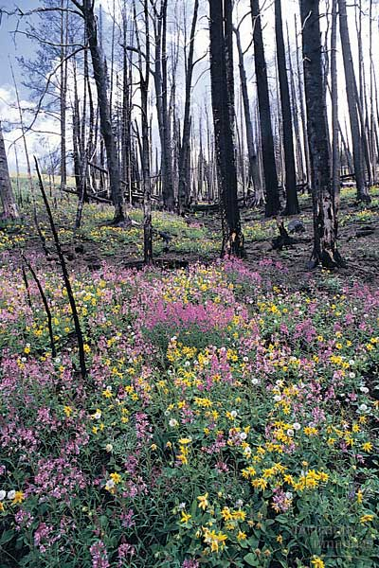

Biogeographic factors:
Latitude – more biodiversity toward the equator due to climate (temperature and water availability) which propagates life as well as the evolutionary history of the communities. (More speciation events have happened in older communities. Tropical communities older than temperate or polar communities).
Evapotranspiration – evaporation of water from soil plus the transpiration of water from plants, correlates with biodiversity.
Species-area curve – larger areas have more biodiversity, if all other factors are equal.
Island equilibrium model – shows immigration and extinction rates as a function of island size and distance from the mainland. The intersection between the rates is how many species the island should support.

Pathogens – disease causing microorganisms.
Zoonotic pathogens – transferred from animals to humans.
Vector – intermediate carrier.

Hemlock woolly adelgid is a good example of a pathogen affecting our local community.

