Chapter 55 Ecosystems

Ecosystem – all living things as well as the abiotic factors within an area.

Primary producers – autotrophs; ex. Plants and algae.
Primary consumers – herbivores.
Secondary consumers – Carnivores that eat herbivores.
Tertiary consumers – Carnivores that eat other carnivores.
Detritivores – decomposers, ex. Prokaryotes and fungi.
(Detritus – nonliving organic material).

Primary production – amount of light energy converted to organic compounds during a given time period AKA gross primary production (GPP).
Net primary production (NPP) – GPP minus energy used by the primary producers for respiration (R): NPP = GPP – R.

In aquatic ecosystems: Nutrient availability determines marine primary production as light is fairly consistent in the photic zone.
Limiting nutrient – element that must be added for production to increase, usually N or P. Upwelling, where nutrient-rich deep waters circulate to the ocean surface, have very high primary production. (Make best fishing grounds).
Photic zone – aquatic area penetrated by light.
In lakes, eutrophication – increased P or N, which leads to overgrowths of cyanobacteria and algae (algal blooms), caused by sewage, poor farming practices, or other pollution.
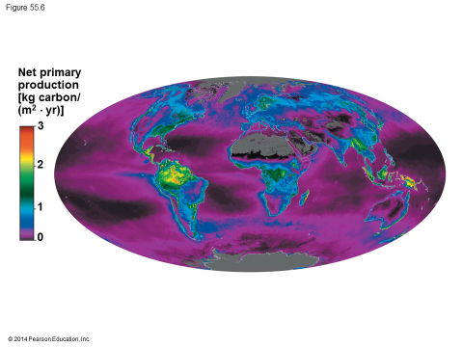
In terrestrial ecosystems: Temperature and moisture main factors.
Actual evapotranspiration – annual amount of water transpired by plants and evaporated from a landscape in millimeters. Positive relationship with net primary production.
N and P can also be limiting nutrients here as well.

Energy Transfer
Secondary production – amount of chemical energy converted to their own biomass during a given time period.
Production efficiency – percentage of energy stored in food not used for respiration. Mammals & birds usually low 1-3%, fish ~10%, insects ~40% of >.

Production efficiency = Net secondary production X 100%
Assimilation of primary production
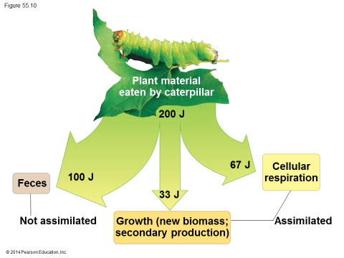

Trophic efficiency – percentage of production transferred from one level to the next, usually 10%.
Turnover time – small standing crop compared to their production.

Turnover time = standing crop/production (g/m²/g/m² x day)

Should humans eat meat? “Estimates of Earth’s human carrying capacity depend greatly on our diet…”

Green World Hypothesis – idea that terrestrial herbivores consume relatively little plant biomass because they are held in check by a variety of factors, including predators, parasites, and disease.
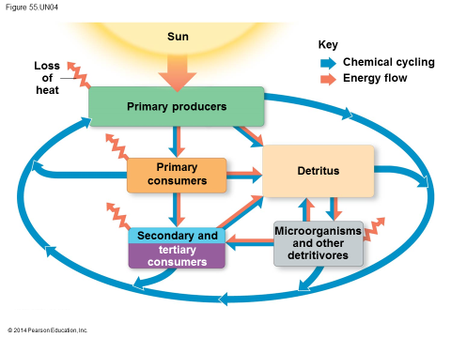

Matter cycling
Biogeochemical cycles – nutrient cycles that include both biotic and abiotic components, ex. Water, N, C, and P.
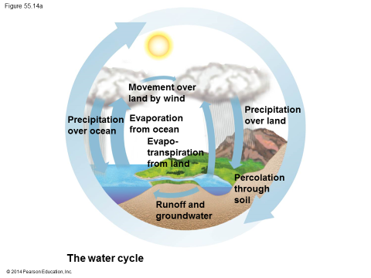
Water Cycle :
Reservoirs – ocean 97%, glaciers and polar ice caps 2%, lakes, rivers, groundwater 1%, atmosphere negligible.
Key Processes – evaporation, transpiration, precipitation, surface and groundwater flow.
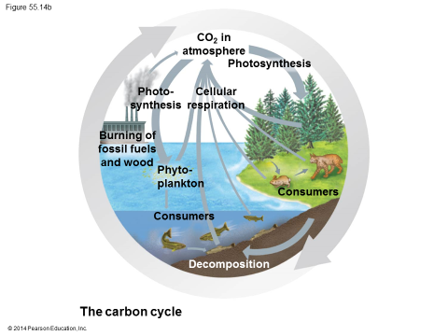
Carbon Cycle:
Reservoirs – fossil fuels, soils, sediments of aquatic ecosystems, oceans, plant and animal biomass, atmosphere. Largest reservoir is sedimentary rocks such as limestone; however, this pool turns over very slowly.
Key Processes – photosynthesis, volcanoes, burning of fossil fuels.
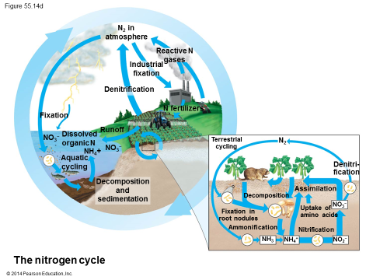
Terrestrial Nitrogen Cycle:
Reservoirs – atmosphere 80%, soils and sediments of lakes, rivers, and oceans, surface water and groundwater, and the biomass of living organisms.
Key processes – Nitrogen fixation – conversion of N₂ by bacteria to forms used to make nitrogenous organic compounds. Some N fixed by lightning. N fertilizer, precipitation, and blowing dust. Ammonification – decomposes organic N to NH₄⁺. Nitrification – NH₄⁺ converted to NO₃⁻ (nitrate) by nitrifying bacteria. Denitrification – anaerobic bacteria use NO₃⁻ instead of O₂ releasing N₂ gas.
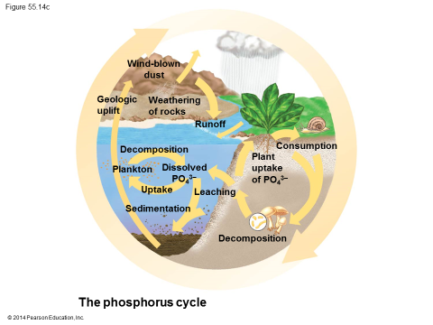
Phosphorus Cycle:
Reservoirs – most in sedimentary rocks of marine origin, also soils, oceans, and in organisms. Cycling is localized in ecosystems.
Key processes – weathering of rocks, decomposition, excretion, dust or sea spray.

Hubbard Brook Experimental Forest – see p 1235, effects of deforestation on nutrient cycling. (More N in runoff, Ca lost.)

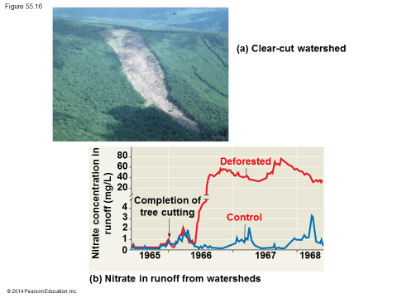
Human Activities: now, most chemical cycles influenced more by human activities than by natural processes.
Agriculture and Nitrogen Cycling
Soils become exhausted due to prolonged agriculture (time frame soil dependent) esp. for N due to removal of plant biomass. However, humans have more than doubled supply of fixed N to primary producers. Most N from fertilizers, then fossil fuel combustion (releases nitrogen oxides which enter atmosphere and dissolve in rainwater), increased legume growing also makes more fixed N.
Eutrophication problem. Critical load – amount of added nutrient, usually N or P.

Acid Precipitation
Caused by burning of wood and fossil fuels including coal and oil which releases oxides of sulfur and nitrogen that react with water in the atmosphere forming sulfuric and nitric acid. Acid precipitation – pH < 5.2. Results in lowered aquatic pH and affects soil chemistry (nutrient leaching esp. calcium).

Toxins in the Environment
Biological magnification – toxins become more concentrated in successive trophic levels (as some toxins are fat soluble).
- DDT banned in the US in 1971. (Rachel Carson, Silent Spring). Birds egg shells deficient in calcium, reduced many to near extinction.
- Mercury pollution changed to methylmercury by bacteria. Builds up in tissues of fish; toxic to humans.

Greenhouse Gases and Global Warming
FACTS-I Experiment (Duke, 1995) showed that increased CO₂ levels increased plant production but not as much as thought previously. Other limiting factors such as N needed.
Greenhouse effect – retention of some solar heat (absorbed infrared radiation) keeps Earth about 30 degrees warmer.
Global warming – increased greenhouse gases will cause polar ice caps melting, flooding, more fires, shift in climates, etc. if we cannot limit our production of CO₂ and methane. Deforestation exacerbates this.

Depletion of Atmospheric Ozone
Ozone, O₃, in the stratosphere thinning since 1970’s. Caused by CFC’s, chlorofluorocarbons, chemicals used in refrigeration, aerosols, and manufacturing. Results in less UV protection. Humans have more skin cancer and cataracts, plants and phytoplankton also damaged by excess UV. Many nations are producing no more CFC’s, but it does not decompose easily and will be a problem for at least another 50 years.

