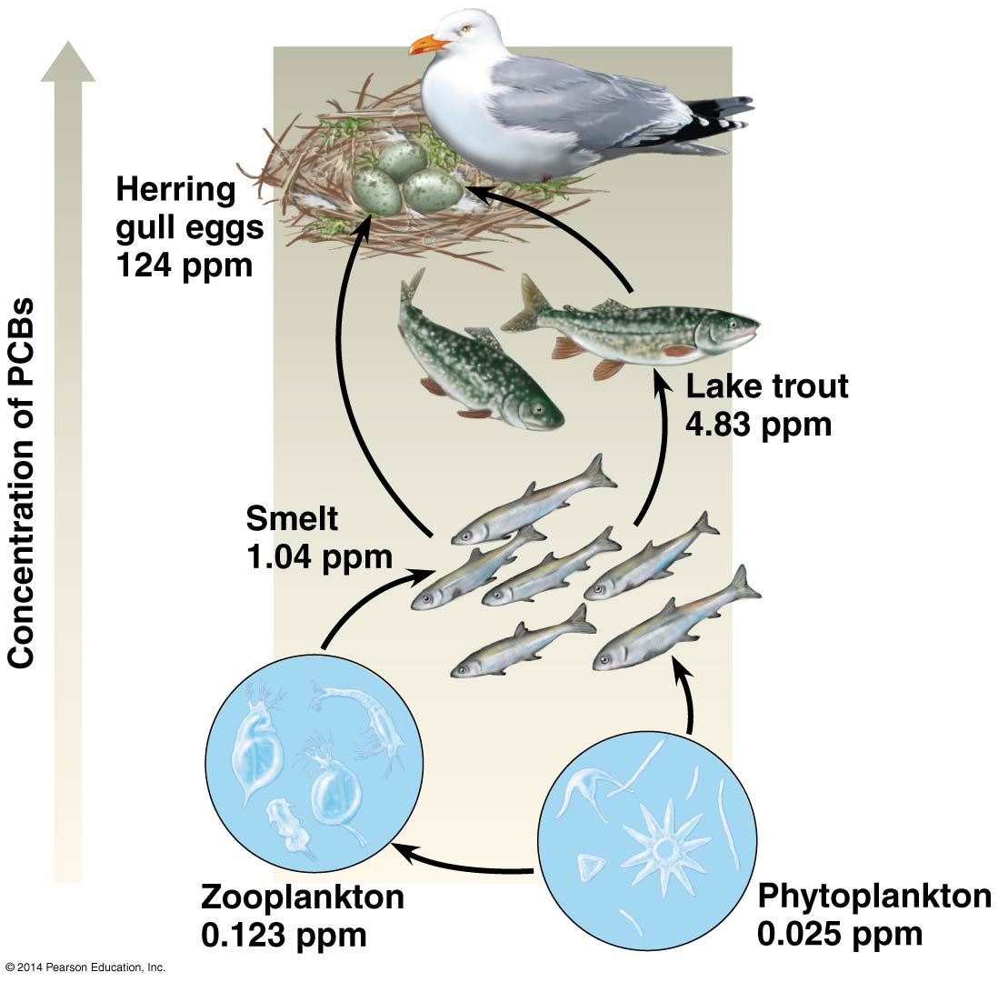
Chapter 56.1 and 56.4 Conservation and Restoration Ecology

56.1 Human activities threaten Earth’s biodiversity
Three levels of biodiversity:
- Genetic diversity – includes variation within a population and also variation between populations often associated with adaptations to local conditions. Losing a population may lose diversity for the species. (Ex. Plant breeders screened 7,000 populations of rice and its close relatives to find resistance to the grassy stunt virus. They found resistance in Indian rice and used that to breed the trait into commercial rice varieties. That population of Indian rice is probably extinct in the wild today).
- Species diversity – the variety of species in an ecosystem or throughout the biosphere.
- Ecosystem diversity – the variety of the biosphere’s ecosystems. Ex. Since European colonization, more than 50% of wetlands in the US have been drained and converted to other ecosystems, primarily agricultural ones.
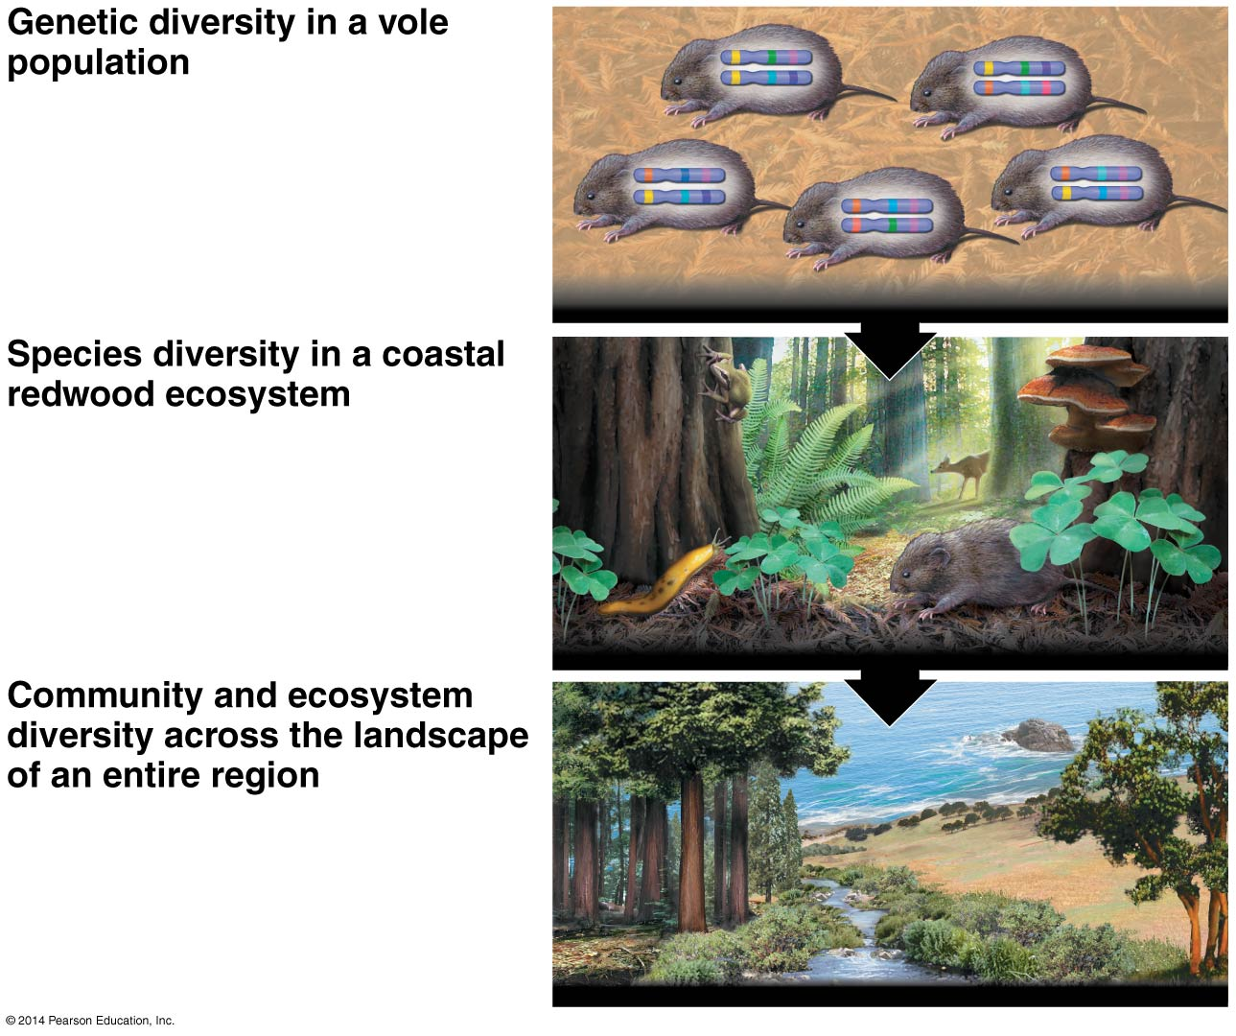
Three threats to biodiversity:
- Habitat lost – biggest threat; includes habitat fragmentation (dividing the habitat).
- Introduced species – exotic species or non-native species.
- Overexploitation – overhunting, overfishing, or over-collecting species. Ex. Elephants, whales, rhinos while they have low reproductive rates.

(56.4) Restoration ecology attempts to restore degraded ecosystems to a more natural state more quickly. Given enough time, many ecosystems may recover via ecological succession.
Bioremediation – using organisms such as prokaryotes, fungi, or plants to detoxify polluted ecosystems.
Biological augmentation – determining what’s needed in an ecosystem and adding it. Ex. Adding N fixing plants to add N back.

